**Prepared by Houston H. Stokes** for a course using Robert Gordon **Macroeconomics**.

These notes containing teaching material copyrighted by Pearson for use with Gordon's

text as well as added material on a variety of subjects.

**Draft date 21 November 2016**

**Goal of the Notes: Allow the student to have an outline of the key ideas and solutions to the problems.**

**Fundamentals of Macroeconomics:**

Macroeconomics studies the aggregate economy - how and why the economy grows and fluctuates over time. Macro Theory provides a means by which an informed person can make predictions on the economic future.

Theory sets up simplified models which can determine the direction or movement of focus variables using (graphical models) or the numerical values of focus variables (numerical models). Econometric models can be estimated using econometrics. In most cases the only statistics needed is mean, variance and OLS. OLS models can be estimated using EXCEL, Stata, Matlab and many other systems.

**Key facts:**

Figure 1-1 shows that when the actual real GDP > Natural Real GDP => Get inflation. Unemployment is the mirror image of inflation. The measure of unemployment is impacted by the labor force participation rate, which if it falls will show that measured unemployment in decreasing.

Figure 1-6 documents Real GDP and unemployment in the period 1900 to the present. Note that the current very serious recession does not compare in its magnitude to the 1930's. Figure 1-7 shows this in more detail. The currently unemployment people are disproportionately the younger and minority workers. Why might this be the case? More of this will be discussed in Chapter 2

Figure 1-8 documents the German Hyper inflation. Unexpected inflation results in a wealth transfer from whose with fixed assets such as pensions to those with debts. While the major cause was printing money, the treaty ending WWI caused the "transfer problem.". These experiences contributed to the rise of national socialism. From 1865-1896 the US had deflation. What were the causes of this?

Figure 1-9 shows differences in growth between South Korea and the Philippines

Economic Growth

Real GDP = Nominal GDP / P where P = the implicit price deflator. Check the appendix to Chapter 2 on the differences between a Lasperse price deflator and a chain weighted price deflator.  is the Lasperse index and  is the chain weighted index.



The geometric average is often used.

Since the price index requires an appropriate base. There are a number of potential problems.

1. The base may not be representative over time due to relative price changes.

2. The base may not be representative over time due to taste changes.

3. The quality of the goods may change so that valid comparisons across periods are not possible.

Historical plots of real GNP and unemployment show the historical record over a longer period than shown in the book.

Prices are measured using an appropriate price index. Common ones are the consumer price index and the GNP deflator

Below is listed the real GDP data and some summary graphs. Since the population has increased, it is hard to compare different points. The inflation can be calculated as 

where .





The unemployment rate during the 1930's depression is an outlier. The economic cost was magnified due to the fact that there were many one earner families. The unemployment rate is impacted by the labor force participation rate which in recent years has been falling. Which direction is the bias?

Inflation is shown below for a long historical period.



The below listed data expands what is in the text. The goal is to give you historical perspective.

+------------------------------------------------------------------------------+

| year gdp real_gdp gdp_dif unempl inflation nat_gdp nat_ump |

|------------------------------------------------------------------------------|

1. | 1875 8.9 138.8 6.4 . . 136.9 . |

2. | 1876 8.6 140.4 6.1 . -.046875 145.7 . |

3. | 1877 8.8 144.8 6.1 . 0 155.1 . |

4. | 1878 8.6 151 5.7 . -.0655738 165.1 . |

5. | 1879 9.4 169.5 5.5 . -.0350877 175.7 . |

|------------------------------------------------------------------------------|

6. | 1880 11 189.6 5.8 . .0545455 187 . |

7. | 1881 11.3 196.3 5.8 . 0 192.6 . |

8. | 1882 12.4 208.7 5.9 . .0172414 198.3 . |

9. | 1883 12.2 213.9 5.7 . -.0338984 204.2 . |

10. | 1884 11.9 217.8 5.5 . -.0350877 210.2 . |

|------------------------------------------------------------------------------|

11. | 1885 11.7 219.4 5.3 . -.0363636 216.4 . |

12. | 1886 12 226 5.3 . 0 222.9 . |

13. | 1887 12.6 236.2 5.3 . 0 229.5 . |

14. | 1888 12.7 235.1 5.4 . .0188679 236.3 . |

15. | 1889 13.5 249.7 5.4 . 0 243.3 . |

|------------------------------------------------------------------------------|

16. | 1890 13.4 253.2 5.3 4 -.0185185 250.5 4.5 |

17. | 1891 13.8 261.4 5.3 5.4 0 257.9 4.5 |

18. | 1892 14.3 273.8 5.2 3 -.018868 267.7 4.5 |

19. | 1893 14.3 273.7 5.2 11.7 0 277.8 4.5 |

20. | 1894 13.1 265.7 4.9 18.4 -.0576923 288.4 4.5 |

|------------------------------------------------------------------------------|

21. | 1895 14.5 296.8 4.9 13.7 0 299.3 4.5 |

22. | 1896 14.2 290 4.9 14.4 0 310.6 4.5 |

23. | 1897 15.1 313.7 4.8 14.5 -.0204081 322.4 4.5 |

24. | 1898 15.7 321.2 4.9 12.4 .0208333 334.6 4.5 |

25. | 1899 17.8 358.4 5 6.5 .0204081 347.3 4.5 |

|------------------------------------------------------------------------------|

26. | 1900 18.5 365.4 5.1 5 .02 360.5 4.5 |

27. | 1901 20.9 410.1 5.1 4 0 374.5 4.5 |

28. | 1902 21.6 417.2 5.2 3.7 .0196078 389 4.5 |

29. | 1903 22.8 429.2 5.3 3.9 .0192308 404.1 4.5 |

30. | 1904 23.9 445.5 5.4 5.4 .0188679 419.8 4.5 |

|------------------------------------------------------------------------------|

31. | 1905 26.1 486.2 5.4 4.3 0 436.1 4.6 |

32. | 1906 28 506.3 5.5 1.7 .0185185 453 4.6 |

33. | 1907 28.8 498.5 5.8 2.8 .0545455 470.6 4.6 |

34. | 1908 26.6 471.2 5.7 8 -.0172414 488.9 4.6 |

35. | 1909 29.8 526.2 5.7 5.1 0 507.8 4.6 |

|------------------------------------------------------------------------------|

36. | 1910 31.1 528.4 5.9 5.9 .0350878 527.5 4.6 |

37. | 1911 32 545.3 5.9 6.7 0 548 4.6 |

38. | 1912 34.7 576.8 6 4.6 .0169491 569.3 4.6 |

39. | 1913 36.4 599.5 6.1 4.3 .0166667 591.4 4.6 |

40. | 1914 34.1 554.1 6.2 7.9 .0163934 608.7 4.6 |

|------------------------------------------------------------------------------|

41. | 1915 36.2 574.6 6.3 8.5 .0161291 626.5 4.6 |

42. | 1916 45.9 667.8 6.9 5.1 .0952381 644.8 4.6 |

43. | 1917 54.9 667.6 8.2 4.6 .1884058 663.7 4.6 |

44. | 1918 69.5 719 9.7 1.4 .1829268 683.1 4.7 |

45. | 1919 77 698.2 11 1.4 .1340206 703.1 4.7 |

|------------------------------------------------------------------------------|

46. | 1920 86.9 683.3 12.7 5.2 .1545454 723.7 4.7 |

47. | 1921 73 659.3 11.1 11.7 -.1259842 744.9 4.7 |

48. | 1922 72.7 706.5 10.3 6.7 -.0720721 766.7 4.7 |

49. | 1923 85.3 805.5 10.6 2.4 .0291262 789.1 4.7 |

50. | 1924 87.6 826.8 10.6 5 0 812.2 4.7 |

|------------------------------------------------------------------------------|

51. | 1925 91.1 845.4 10.8 3.2 .0188679 836 4.7 |

52. | 1926 97.2 896.2 10.8 1.8 0 860.4 4.8 |

53. | 1927 96 901.2 10.7 3.3 -.0092593 885.6 4.8 |

54. | 1928 97 917.9 10.6 4.2 -.0093457 911.6 4.8 |

55. | 1929 103.6 976.9 10.6 3.2 0 938.2 4.8 |

|------------------------------------------------------------------------------|

56. | 1930 91.2 892.6 10.2 8.9 -.0377359 972 4.8 |

57. | 1931 76.5 835.1 9.2 16.3 -.0980392 1007 4.8 |

58. | 1932 58.7 725.6 8.1 24.1 -.1195652 1042.8 5 |

59. | 1933 56.4 716.4 7.9 25.2 -.0246914 1081.1 5 |

60. | 1934 66 794.6 8.3 22 .0506329 1121.5 5 |

|------------------------------------------------------------------------------|

61. | 1935 73.3 864.9 8.5 20.3 .0240964 1162.4 5 |

62. | 1936 83.8 978.3 8.6 17 .0117648 1203.5 5 |

63. | 1937 91.9 1028.3 8.9 14.3 .0348836 1247.7 5.1 |

64. | 1938 86.1 992.4 8.7 19.1 -.0224719 1291.2 5.1 |

65. | 1939 92.2 1073.2 8.6 17.2 -.0114942 1338.5 5.1 |

|------------------------------------------------------------------------------|

66. | 1940 101.4 1166.6 8.7 14.6 .0116278 1386.1 5.1 |

67. | 1941 126.7 1365.7 9.3 9.9 .0689656 1439.2 5.1 |

68. | 1942 161.9 1618.2 10 4.7 .0752688 1490.9 5.1 |

69. | 1943 198.6 1883 10.5 1.9 .05 1546.5 5.2 |

70. | 1944 219.8 2035.6 10.8 1.2 .0285714 1601.8 5.2 |

|------------------------------------------------------------------------------|

71. | 1945 223 2011.9 11.1 1.9 .0277778 1657.9 5.2 |

72. | 1946 222.2 1791.9 12.4 3.9 .117117 1719.4 5.2 |

73. | 1947 244.1 1776.2 13.7 3.9 .1048387 1782.9 5.2 |

74. | 1948 269.1 1854.1 14.5 3.8 .0583942 1842.7 5.3 |

75. | 1949 267.2 1844.5 14.5 6.1 0 1911.2 5.3 |

|------------------------------------------------------------------------------|

76. | 1950 293.7 2005.6 14.6 5.2 .0068966 1982.1 5.3 |

77. | 1951 339.3 2161.4 15.7 3.3 .0753424 2055.7 5.3 |

78. | 1952 358.3 2243.9 16 3 .0191083 2139 5.3 |

79. | 1953 379.3 2347 16.2 2.9 .0125 2226.5 5.3 |

80. | 1954 380.4 2332.6 16.3 5.6 .0061727 2311.6 5.3 |

|------------------------------------------------------------------------------|

81. | 1955 414.7 2500.2 16.6 4.4 .018405 2401.8 5.3 |

82. | 1956 437.4 2549.5 17.2 4.1 .0361446 2488.3 5.3 |

83. | 1957 461.1 2601.3 17.7 4.3 .0290698 2578.5 5.3 |

84. | 1958 467.2 2577.8 18.1 6.8 .0225988 2675.6 5.3 |

85. | 1959 506.6 2762.3 18.3 5.5 .0110497 2773.6 5.3 |

|------------------------------------------------------------------------------|

86. | 1960 526.4 2830.7 18.6 5.5 .0163935 2878.1 5.3 |

87. | 1961 544.8 2897.1 18.8 6.7 .0107526 2988.3 5.4 |

88. | 1962 585.7 3072.6 19.1 5.6 .0159575 3102.3 5.5 |

89. | 1963 617.8 3206.9 19.3 5.6 .0104711 3224.1 5.6 |

90. | 1964 663.6 3392.1 19.6 5.2 .0155441 3352.2 5.6 |

|------------------------------------------------------------------------------|

91. | 1965 719.1 3610.1 19.9 4.5 .0153061 3486.6 5.7 |

92. | 1966 787.7 3845.4 20.5 3.8 .0301508 3625.9 6 |

93. | 1967 832.4 3942.2 21.1 3.8 .0292683 3760.3 6.2 |

94. | 1968 909.8 4133.2 22 3.6 .042654 3904.8 6.3 |

95. | 1969 984.4 4261.7 23.1 3.5 .05 4053.2 6.3 |

|------------------------------------------------------------------------------|

96. | 1970 1038.3 4269.9 24.3 5 .051948 4206.7 6.2 |

97. | 1971 1126.8 4413.1 25.5 6 .0493827 4372.5 6.2 |

98. | 1972 1237.9 4647.8 26.6 5.6 .0431373 4544.8 6.1 |

99. | 1973 1382.3 4917.1 28.1 4.9 .056391 4720.4 6.1 |

100. | 1974 1499.5 4890.1 30.7 5.6 .0925267 4890.3 6.2 |

|------------------------------------------------------------------------------|

101. | 1975 1637.7 4879.5 33.6 8.5 .0944625 5071.3 6.1 |

102. | 1976 1824.6 5141.3 35.5 7.7 .0565477 5245.7 6.2 |

103. | 1977 2030.1 5377.6 37.8 7.1 .0647887 5421.5 6.3 |

104. | 1978 2293.8 5677.7 40.4 6.1 .0687831 5602 6.4 |

105. | 1979 2562.2 5855 43.8 5.9 .0841584 5784.1 6.4 |

|------------------------------------------------------------------------------|

106. | 1980 2788.1 5838.8 47.8 7.2 .0913242 5972 6.5 |

107. | 1981 3126.8 5987.2 52.2 7.6 .0920502 6165.5 6.3 |

108. | 1982 3253.2 5870.9 55.4 9.7 .0613027 6380 6.1 |

109. | 1983 3534.6 6136.1 57.6 9.6 .0397111 6571.7 6 |

110. | 1984 3930.9 6577.2 59.8 7.5 .0381945 6756.9 6 |

|------------------------------------------------------------------------------|

111. | 1985 4217.5 6849.3 61.6 7.2 .0301003 6954.7 6 |

112. | 1986 4460.1 7086.6 62.9 7 .0211039 7150.6 6.1 |

113. | 1987 4736.4 7313.3 64.8 6.2 .0302067 7346.4 6.2 |

114. | 1988 5100.4 7613.9 67 5.5 .0339506 7552.8 6.3 |

115. | 1989 5482.1 7885.9 69.5 5.3 .0373134 7773.3 6.3 |

|------------------------------------------------------------------------------|

116. | 1990 5800.5 8033.8 72.2 5.6 .0388489 8004.4 6.2 |

117. | 1991 5992.1 8015.1 74.8 6.9 .0360112 8249.5 6 |

118. | 1992 6342.3 8287 76.5 7.5 .0227272 8501.2 5.8 |

119. | 1993 6667.4 8523.5 78.2 6.9 .0222222 8753.5 5.6 |

120. | 1994 7085.2 8870.7 79.9 6.1 .0217392 9007.3 5.5 |

|------------------------------------------------------------------------------|

121. | 1995 7414.7 9093.8 81.5 5.6 .020025 9274.5 5.4 |

122. | 1996 7838.5 9434 83.1 5.4 .0196319 9559.2 5.3 |

123. | 1997 8332.4 9854.4 84.6 4.9 .0180505 9863.6 5.3 |

124. | 1998 8793.5 10283.5 85.5 4.5 .0106383 10188 5.2 |

125. | 1999 9353.5 10779.9 86.8 4.2 .0152047 10530.8 5.1 |

|------------------------------------------------------------------------------|

126. | 2000 9951.5 11226 88.6 4 .0207373 10881.8 5.1 |

127. | 2001 10286.2 11347.2 90.7 4.7 .023702 11228.5 5.1 |

128. | 2002 10642.3 11552.9 92.1 5.8 .0154355 11578.9 5.1 |

129. | 2003 11142.1 11840.7 94.1 6 .0217155 11925.3 5.1 |

130. | 2004 11867.8 12263.9 96.8 5.5 .0286929 12266.7 5.1 |

|------------------------------------------------------------------------------|

131. | 2005 12638.4 12638.4 100 5.1 .0330578 12605.5 4.9 |

132. | 2006 13398.9 12976.3 103.3 4.6 .033 12945.2 4.8 |

133. | 2007 14061.8 13228.9 106.3 4.6 .0290416 13295.2 4.8 |

134. | 2008 14369.1 13228.9 108.6 5.8 .0216368 13642.1 4.8 |

135. | 2009 14119 12880.5 109.6 9.3 .0092081 13987.5 5.1 |

|------------------------------------------------------------------------------|

136. | 2010 14660.2 13248.7 110.7 9.6 .0100365 14341.5 5.3 |

+------------------------------------------------------------------------------+

Important questions:

1. At what time period is real_gdp = gdp ? Why?

2. Why was inflation negative in the 1800's? What fixed this? Which regions did this favor? Why?

3. What were the periods of high unemployment? What are the issues in measuring unemployment?

**Measuring Economic Performance: Output and Income**

* Gross Domestic Product => Production during a particular period of time. Can be measured as spending on goods and services, or production in different industries or income earned by different groups.
* GDP = Y = C + I + G + X
* X = exports – imports
* C = durable goods + nondurable goods + services
* I = fixed investment + inventory investment
* fixed investment = nonresidential + residential
* Investment is a flow of new capital added to stock of capital. Net investment = gross investment - depreciation.
* Investment = (Capital stock)t – (capital stock)t-1 = 
* Inventory investment = change in stock of inventories
* X > (<) 0 => trade surplus (trade deficit)
* Real GDP vs nominal GDP. How would these terms be used?
* GDP = Σ value added = Σ final products = Σ income
* GNP = GDP + net payments of factor incomes from abroad.

# Accounting

F = Government transfers to the private sector

N'= interest on government debt

T = taxes

X = net exports

V = factor income and transfer payments from abroad (net)

Sp = Private Savings

Sg= Government savings

Sr= Rest of World savings

Sp = (Y + V + F + N' -T) - C

Sg = (T - F - N') - G

Sg > (<) => budget surplus (budget deficit)

Sr = - X - V = net foreign investment of the United States

Sp+Sg+Sr =(Y + V + F + N' - T) - C +(T - F - N' - G) - V – X

= Y - C - G - X

M = money, ΔM = Mt - Mt-1

B = government bonds, ΔB = Bt - Bt-1

Sg = -(ΔM + ΔB), Gov deficit => sell bonds and or print money

Sp = I + ΔM + ΔBp (Bp = private bonds)

Sr = ΔBr (Br = foreign holdings of U. S. government bonds)

Sp+Sg+Sr =I + ΔM + ΔBp + - ΔM -ΔB + ΔBr

Exchange rate = dollar price of one unit of the foreign currency. Can be calculated as a trade weighted exchange rate

## Review: Monitoring the Economy; Inflation and Employment

Inflation =

CPI measures cost of a basket of consumer goods.

PPI measures cost of a basket of producer goods.

**Measuring Price** The CPI measures price changes by buying a market basket of goods at different times. Three known problems are:

1. Tastes may change over time but same basket is bought.
2. Relative prices may change but the same basket is bought
3. Price changes involve subtle income changes that give rise to income effects that will alter the mix of goods bought.

The CPI for period t, Pt is calculated with the Laspeyres formula:



If in place of the above equation the quantities could have been adjusted every year as in the Paasche formula



which is not possible to calculate but would avoid the tastes bias and the relative price bias.

How is the Chain weighted index defined? What are its advantages, disadvantages?

Laspeyres index overstates price increase due to:

1. Not changing basket as relative prices change.

2. Not controlling for quality changes.

3. Not adjusting for taste changes

Paasche price index cannot be used historically. Why?

What is difference between GNP deflator and CPI index?

Nominal GDP / real GDP = GDP deflator

GDP deflator does not include oil import prices, CPI does.

Since hours per week varies, employment is not a perfect measure of economic activity since hours per week changes.

HHS found that in Detroit there was great % change in employment versus % change in hours than in Chicago. => more labor hoarding in Chicago. # employed * hours per week is a better measure BUT this does not take into account differences in overtime.

* **Key labor terms:**

Labor force = # of persons GE 16 who are working or unemployed.

Unemployment rate = % of labor force that is unemployed. **Looks at only the people actively looking for work. If people get discouraged and stop looking unemployment goes .**

Labor force participation rate = % of working-age population that is in labor force. **This has decreased in the last 10 years.**

Even when real GDP = potential GDP, unemployment is not zero.

Example: Net rental income of persons - 24.1

Depreciation 669.1

Compensation of employees 3780.4

Personal Consumption expenditures 4378.2

Sales and excise taxes 525.3

Business transfer payments 28.7

Statistical discrepancy 2.3

Gross Private domestic investment 882.0

Exports of goods and services 659.1

Net subsidies of government business 9.0

Government purchases of goods and services 1148.4

Imports of goods and services 724.3

Net interest 399.5

Proprietor's income 441.6

Corporate profits 485.8

Net factor income from rest of world 5.7

a. GDP = C+I+G+EX-IM = 4378.2 + 882.0 + 1148.4 + 659.1 - 724.3 = 6343.4

b. NDP = GDP - depreciation = 6343.4 - 669.1 = 5674.3

c NI via expenditure method:

NI = NDP - indirect business tax and nontax liability

- business transfer payments

- statistical discrepancy

+ government subsidy

+ net factor income from rest of world

= 5674.3 – 525.3 - 28.7 – 2.3 + 9.0 + 5.7 = 5132.7

NI via adding the incomes of different people

NI = compensation of employees + proprietors' income

+ net rental income

+ corporate profits

+ net interest

= 3780.4 + 441.6 + 24.1 + 485.8 + 399.5 = 5131.4

The difference is a statistical discrepancy!

# Some Important Models

Balanced budget analysis shows the effect of taxes based on what is bought:

Assume a closed Economy. The usual multiplier is:

# 

# Now assume



t

If 

How are investment, savings, taxes, government expenditure, exports and imports linked?

Define 

As of 2014 the government is running a deficit. This implies that real investment in plant and equipment is less than public and business savings.

Modify 2. to add net exports  and equate to 5 using 2c.



In order to increase net investment at least one other variable in equation 10 must change.

If  then .

More detail on implicit GNP accounting.

Sector\Market Goods Securities Money Int Reserves

Gov T-G Gov Borrow Gov Dishoard Gov dishoard Foreign E =0

Private S-I Private " Private " Private " " E =0

Foreign  Capital Foreign " Increase in Res =0

Outflow =

Foreign

Borrow

Banking  Open Market Money Expansion Foreign exchange

sales by banks Bank dishoarding sales =0

The above generalizes equation 2.5 on page 35 that discusses the "magic equation."

Growth

 labor force adjusted for hours worked

 real capital stock adjusted for utilization

 real output

Cobb-Douglas production function





( implies respectively increasing returns to scale, constant returns to scale decreasing returns to scale.

Assume L and K increase by a factor of  .



If  then if L and K double or  then output doubles or constant returns to scale. If  then output goes up by 4. For more detail see Gordon page 385

Example of an estimation for US data. Note that the Cobb Douglas can be made linear in the logs and estimated by ols



Production functions allows us to make growth projections and whether there will be inflation due to the economy over heating.

=> CALL OLSQ(LNQ TIME LNL LNK :PRINT) $

Ordinary Least Squares Estimation

Dependent variable LNQ

Centered R**2 0.9953526556546336

Adjusted R**2 0.9949543118536022

Residual Sum of Squares 3.752435629889436E-02

Residual Variance 1.072124465682696E-03

Standard Error 3.274331177023326E-02

Total Sum of Squares 8.074365381663048

Log Likelihood 80.11476788750971

Mean of the Dependent Variable 5.687448882493469

Std. Error of Dependent Variable 0.4609591082921007

Sum Absolute Residuals 0.8764362565596846

F( 3, 35) 2498.727614380924

F Significance 1.000000000000000

1/Condition XPX 4.709681286398916E-13

Maximum Absolute Residual 0.1035378657302592

Number of Observations 39

Variable Lag Coefficient SE t

TIME 0 0.52122298E-02 0.22298385E-02 2.3374921

LNL 0 1.3414034 0.91392384E-01 14.677409

LNK 0 0.29237997 0.59843456E-01 4.8857467

CONSTANT 0 -13.064320 3.9108374 -3.3405428

=> ERROR=DEXP(%RES)$

=> YHAT=DEXP(%YHAT)$

=> A=EXP(%COEF(4))$

=> TEST=A*DEXP(%COEF(1)*TIME)*(L**%COEF(2))*(K**%COEF(3))$

=> CALL PRINT('Forecast of output in period 1',TEST)$

Forecast of output in period 1-N

TEST = Array of 39 elements

183.728 173.484 162.172 137.768 137.472 146.296 156.663 170.946

184.538 168.961 182.467 198.871 231.126 259.262 273.318 270.864

256.517 273.420 300.040 315.897 306.224 329.231 359.246 370.695

385.894 372.550 399.904 420.919 426.409 414.913 446.452 464.650

467.084 491.363 505.965 533.945 569.609 614.055 647.604

=> CALL PRINT(' A ',A)$

A

A = 0.21195227E-05

=> CALL TABULATE(TIME Q, YHAT L K LNQ LNL LNK)$

Obs TIME Q YHAT L K LNQ LNL LNK

1 1929. 189.8 183.7 173.3 87.80 5.246 5.155 4.475

2 1930. 172.1 173.5 165.4 87.80 5.148 5.108 4.475

3 1931. 159.1 162.2 158.2 84.00 5.070 5.064 4.431

4 1932. 135.6 137.8 141.7 78.30 4.910 4.954 4.361

5 1933. 132.0 137.5 141.6 76.60 4.883 4.953 4.339

6 1934. 141.8 146.3 148.0 76.00 4.954 4.997 4.331

7 1935. 153.9 156.7 154.4 77.70 5.036 5.040 4.353

8 1936. 171.5 170.9 163.5 79.10 5.145 5.097 4.371

9 1937. 183.0 184.5 172.0 80.00 5.209 5.147 4.382

10 1938. 173.2 169.0 161.5 77.60 5.154 5.085 4.352

11 1939. 188.5 182.5 168.6 81.40 5.239 5.128 4.399

12 1940. 205.5 198.9 176.5 87.00 5.325 5.173 4.466

13 1941. 236.0 231.1 192.4 96.20 5.464 5.260 4.566

14 1942. 257.8 259.3 205.1 104.4 5.552 5.323 4.648

15 1943. 277.5 273.3 210.1 110.0 5.626 5.348 4.700

16 1944. 291.1 270.9 208.8 107.8 5.674 5.341 4.680

17 1945. 284.5 256.5 202.1 102.1 5.651 5.309 4.626

18 1946. 274.0 273.4 213.4 97.20 5.613 5.363 4.577

19 1947. 279.9 300.0 223.6 105.9 5.634 5.410 4.662

20 1948. 297.6 315.9 228.2 113.0 5.696 5.430 4.727

21 1949. 297.7 306.2 221.3 114.9 5.696 5.400 4.744

22 1950. 328.9 329.2 228.8 124.1 5.796 5.433 4.821

23 1951. 351.4 359.2 239.0 134.5 5.862 5.476 4.902

24 1952. 360.4 370.7 241.7 139.7 5.887 5.488 4.939

25 1953. 378.9 385.9 245.2 147.4 5.937 5.502 4.993

26 1954. 375.8 372.5 237.4 148.9 5.929 5.470 5.003

27 1955. 406.7 399.9 245.9 158.6 6.008 5.505 5.066

28 1956. 416.3 420.9 251.6 167.1 6.031 5.528 5.119

29 1957. 422.8 426.4 251.5 171.9 6.047 5.527 5.147

30 1958. 418.4 414.9 245.1 173.1 6.036 5.502 5.154

31 1959. 445.7 446.5 254.9 182.5 6.100 5.541 5.207

32 1960. 457.3 464.7 259.6 189.0 6.125 5.559 5.242

33 1961. 466.3 467.1 258.1 194.1 6.145 5.553 5.268

34 1962. 495.3 491.4 264.6 202.3 6.205 5.578 5.310

35 1963. 515.5 506.0 268.5 205.4 6.245 5.593 5.325

36 1964. 544.1 533.9 275.4 215.9 6.299 5.618 5.375

37 1965. 579.2 569.6 285.3 225.0 6.362 5.654 5.416

38 1966. 615.6 614.1 297.4 236.2 6.423 5.695 5.465

39 1967. 631.1 647.6 305.0 247.9 6.447 5.720 5.513

Supply

W/P

Demand

L* L

Y/P

Production Function

(Y/P)*

L* L

The Demand and Supply of Labor determine the full employment labor L* from which we get full employment (Y/P)*

Example 1. Labor supply = labor demand

a. 1000 + 12 (W/P) = 2000 - 8 (W/P)

20 (W/P) = 1000, W/P = 50,

L = 1000 + 12 * 50 = 1600

b. Y = 100 L.5 => diminishing marginal product since

a 4 * increase in labor => output goes up 2 times

Y = 100 * 1600.5 = 4000

Example 2

ΔY/Y = ΔA/A + .7ΔL/L + .3 ΔK/K

.05 = ΔA/A + .7*.02 + .3 * .04

ΔA/A = .024

If ΔK/K rises by .01 => ΔY/Y rises by .003=.01*.3

If ΔL/L rises by .01 => ΔY/Y rises by .007

Example 3

Y = AL.7K.3 => lnY = lnA + .7 lnL + .3 lnK

Marginal product of capital = .3Y/K

Marginal product of labor = .7Y/L

Labor demand .7Y/L = W/P

Labor share = .7, Capital share = .3

## Fiscal and Monetary Policy in the Growth Model

**Fiscal policy** => Changes in G, T and transfer payments to the private sector (F) and interest payments on debt N'

Budget deficit = G + F + N' – T

**Monetary policy** => Changes in money supply. How do we measure the money supply? (M1, M2 other)? What is the effect of an increase in the amount of credit card debt? lines of credit?

In long run with flexible prices

potential GDP = GDP

GDP depends on labor, capital and technology. **In order for monetary or fiscal policy to have a long run effect, one of these factors must be affected.**

If military spending goes down => no immediate effect on A, L or K. In long run private investment might increase K.

If there was a reduction in R & D, then there may be some slowing in the growth of A.

A reduction in T rates increases worker incentives to work. For a given W/P more labor is supplied.

If prices are flexible => ΔM/M > ΔY/Y => inflation. Inflation can reduce output.

Sinai-Stokes (RES 1972) argued that real balances should be in the production function. They suggested that M/P was a proxy for the financial sector. The effect of the financial sector was to increase economic efficiency. The model estimated was



If  what is the implication?

How might , and *m* be adjusted?

If G increases, everything else equal, the non-governmental share of GDP must decrease.

G (up) everything else = => pressure on interest rate (R) to rise. R increasing => exchange appreciation due to an induced capital inflow. => Foreign goods get cheaper, but our exports get more expensive. Trade balance worsens (X down). In 1980's this happened. As budget deficit increased trade deficit increased.

In long run, increasing the government deficit increases interest rates and crowding out of investment and net exports occurs. In short run there is possible stimulation of the economy.

The level of savings is a positive function of real income. Why?

The level of investment is a negative function of the real interest rate. Why?

* The demand for money  where *i*= nominal interest rate

The **transactions motive** is positively related to real income  . This assumes velocity is fixed.

The **speculative motive** is negatively related to the nominal interest rate . Why is this the case? Hint: think opportunity cost of holding money balances.

**LM Curve equation**

Along the LM curve the demand for money equals the supply of money, which is assumed to be fixed.

M = (hY – fr)P where f > 0, h > 0.

The Federal Reserve determines the money supply. Money is assumed to be currency plus balances in checking accounts.

Given the supply of money, the equilibrium price level is

P = M /(hY* - fr*)

If ΔM/M = 10% => ΔP/P = 10% then **money is neutral**. This is called **classical dichotomy**. This assumes income and interest rates are fixed. If Y were to increase, then the effect on P increasing would be less since the denominator of the price equation has increased. This can be seen from the price equation. In this case

Since ΔY/Y > 0, ΔM/M > ΔP/P.

During the black death in the UK in 1347, 33% of the population died in 6 weeks. The money supply which was gold coins was fixed. What do you predict will happen to the price level in this situation? Why?

An implication of the classical dichotomy is that in the long run nominal variables only influence other nominal variables.

Given Y* = 4000., r* = .05. M =(.3Y-4000r)P , M=1000.

=> P = 1000/((.3*4000) - (4000*.05)) = 1000/1000 = 1

Fed increases M to 1100 => P = 1100/1000 = 1.1

If M = 1000, P = 1.0, k=.3 and f = 4000 =>

1000 = (.3Y - (4000*.05)).

Y = (1000 + 200)/.3 = 4000.

Interest rate increases from .05 to .1.

PNEW = 1000/(.3*4000 - 4000*.1)= 1000 / 800 = 1.25

An increase in the interest rate could be caused by G up.

Given M = 1000, P = 1.0, r* =.05. Y up from 4000 to 4500 then what happens to P?

1000 = (.3*4500 - 4000*.05)PNEW

PNEW = 1000/1150 = .87695652.

=> given money supply, then Y up => P down. (This is what happened in the US after the Civil War (1865-1890))

Problems

Given investment and exports X are negatively related to interest rate. Assume the interest rate is capped at 5% rather than the equilibrium rate of 6%. What is the effect on the level and distribution of output?

Level of output is not changed since K, L or A not influenced initially. However, at 5% there are more claims on output (from investment) than there is output. There must be some rationing. How would the interest rate be held under 6%?

Outward shift in labor supply => output up

Improvement in technology => output up

Increase in money supply => output unchanged. P up

Reduction in tax rate on income => Output does not change initially BUT C crowds out I.

L up since supply curve of labor will shift outward since workers get to keep a greater percentage of their real wage. The net effect is that income will increase.

If Fed wants to maintain the current level of prices.

If potential GDP up => M up

If tax on income up yet potential GDP is constant => M down since L down otherwise P up.

Investment function shifts right => P up. Policy is M down

Foreign demand for US goods up => M down

Effects on price level

Increase in labor supply => P down

Decrease in sensitivity of investment to interest rate P up

Shift outward in Consumption function => P up

Decrease on government purchases =>P down

Increase in the average tariff rate on imports = P up.

**Derivation of IS and LM Curves**

IS Curve = locus of points showing values of interest rate and real income where

I = S.

# LM Curve = Locus of points showing values of interest rate and real income where

# money demand = money supply

Figure 4-4 page 95 shows the intersection of the IS and LM curves that determine equilibrium.

Assume we are at point C where I = S. Now move right to point F. Here interest rate is fixed so I is not changed. However Y has increased thus, I < S. To make I=S we must lower the interest rate to move to point D. Another way to look at the problem is assume you are at point C. Next the interest rate is lowered holding income fixed to move to point G. Here I>S. To get S=I we must increase Y to move to D.

Fiscal policy effects.

Assume recently announced data suggests that the recovery will be stronger (weaker) than expected which will move the IS curve up (down) to intersect the LM at point F (G) with both interest and real income increasing (decreasing). See also figure 4-6.

Monetary Policy effects

If the Federal reserve were to increase (decrease) the money supply the LM curve will move right (left) and intersect the IS curve at point D (C) resulting in higher (lower) real income and lower (higher) interest rates. See figure 4-5

# 

Points to think about:

Points to the right (left) of the LM imply excess demand for (supply of) real balances. To move the LM curve to go through such a point requires either the price level decrease (increase) or the nominal money supply increase (decrease).

The flatter the LM the more powerful fiscal policy since the increase in interest rates will be less and thus not reduce investment as much.

The flatter the IS the more powerful monetary policy since lowing the interest rate will increase investment more.

The full employment level of real income can be drawn on the IS/LM diagram. If the IS-LM intersection point is to the right (left) of this vertical line, there is pressure for prices to rise (fall) to move the LM curve to a point of stable equilibrium.

Define liquidity trap. What is its significance?

**Equation of exchange**  MV=PT. M = money supply. P = price index. V = velocity, T = number of real GNP transactions.

M includes currency and demand deposits. Currently velocity is relatively low and the monetary base has been increased substantially. What happens if velocity increases to its historic level?

M1 = currency, transactions accounts and traveler's checks.

M2 = M1 + savings deposits, money market deposit accounts,

Below are the graphs of v1 = gnp/m1, v2 = gnp/m2 , m1 and m2.

Stata can be used to access Gordon_stat.csv for which is appendix A in your text. The commands

tsset year

gen v1 = gnp /m1

gen v2 = gnp/m2

tsline v1 v2

tsline m1 m2

. regress v2 year m2

Source | SS df MS Number of obs = 136

-------------+------------------------------ F( 2, 133) = 60.24

Model | 22.3632759 2 11.1816379 Prob > F = 0.0000

Residual | 24.689111 133 .185632414 R-squared = 0.4753

-------------+------------------------------ Adj R-squared = 0.4674

Total | 47.0523869 135 .348536199 Root MSE = .43085

------------------------------------------------------------------------------

v2 | Coef. Std. Err. t P>|t| [95% Conf. Interval]

-------------+----------------------------------------------------------------

year | -.0155146 .0014186 -10.94 0.000 -.0183205 -.0127086

m2 | .0002115 .0000279 7.57 0.000 .0001562 .0002668

_cons | 31.8149 2.73246 11.64 0.000 26.4102 37.2196

------------------------------------------------------------------------------

Over the years of the data V2 has declined. It has been positively related to M2. Why might this be the case? Stata was used to build the graph.



: 

Fiscal and Monetary Policy:

Government reduces tax to stimulate economy since IS=LM to left of full employment line.

1. LM curve does not change and slopes upward. => increase in interest rate. Real income up

2. LM curve moves left due to tighter monetary policy. Increases interest rate. Real income up. Balance of payments improves due to a capital inflow. Note if money is reduced still further we can just have an effect on interest rates. Here the stimulation from Fiscal Policy is choked off.

3. LM curve moves right. Interest rate unchanged. Real income up. Demand for imports increases due to increase in real income.

Fiscal policy hard to turn off and on due to political issues and the fact that there may not be "shovel ready" projects.

Key Formulas

Equation of LM



Equation of IS (See page 87). For multiplier see appendix 3



Problem 5 page 115



a. 



b.



c. IS Curve 

d. Slope IS 

e. LM Curve



f. Slope of LM =.01

g & h. Solve LM equation and IS equation for  and 





The Excel file open IS-LM Solution.xlsx will solve this problem and # 10.

It can be modified to add new features.

**Financial Crisis**

Pages 102-103 outline the dynamics of the recent financial crisis as it pertains to housing.

Expectations of Fed policy for the Federal Funds rate drives the 10 year bond rate. In the period 2002-2004.5 the FF rate was very low. See the effect on housing starts. The increase in the federal funds rate starting in 2004.5 from 1.0 to 5.25 in 2006.5 was one reason for the fall-off of housing starts. Home owners who had adjustable mortgages found that they were having trouble "flipping" their houses due to decreased demand, just when their mortgage rate shot up. As residential investment decreased the IS curve shifted left. (). There were many other causes that will be discussed in class.

Read Carefully pages 110-111.

1. US in 1935-1940. Interest rate was very low. Monetary policy can do no more.

2. Japan since 1992. Worried about deficits did not attempt using both monetary policy and fiscal policy where the central bank bought Government Bonds.

3. US Since 2009 has Federal Funds rate near zero. Has experimented with trying to lower longer rates. Quantitative easing. A massive fiscal stimulus, finance by Federal Reserve purchase of bonds was not attempted. The modest fiscal stimulus attempted was used to help State and Local Governments.

**Financial Markets, Financial Regulation and Economic Instability.**

US Economy reached a peak in late 2007. In September 2008 there was a financial crisis on Wall Street.

The effect of the financial sector on the Economy lies through the wealth effect which impacts autonomous consumption which will shift the IS curve left if real wealth falls. Families will be attempting to save to restore lost real wealth.

Effect of housing values falling.

Effect of stock prices falling 50%.

End of cash-out mortgage refinancing which eliminates a previous stimulus to consumption.

Growing unwillingness of banks to grant loans due to insolvency considerations.





Key terms

**Securitization** The process of combining many different debt instruments like home mortgages into a pool of hundreds or thousands of individual contracts, and then selling new financial instruments backed by the pool, for instance mortgage backed securities.

**Output gap** The ratio of actual real GDP to natural real GDP.

**Subprime** Lending to individuals who would not normally qualify.

**Quantitative Easing** Fed adding reserves to bank's balance sheets. The goal was to stimulate lending.

Some characteristics of the crisis.

Banking crisis

Domestically held federal, state and local debt was large and growing.

Foreign owned US Bonds are in the hands of countries running a trade surplus with the US (e.g. China). Will they suddenly start dumping US bonds?

US Education system increasingly broken. The skills (human capital) of graduates do not line up with market demand.

44 of our 50 states are in various degrees of dire financial shape. States cannot issue money (monetize their way out of a crisis). Revenue sharing stopped in 1987. Illinois is the worst of the 50 states with the pension crisis basically unsolved.

The Social Security system is based on historically shorter life spans. A major overhaul needed before it is too late. How might changes be implemented? An inflation tax is a possible “solution.”

It is not clear that the medical care system has been fixed.

It is not clear that the Financial reform bill has sufficiently isolated commercial banking from investment banking. Glass Steagall repealed. Up tick rule not in effect.

Robert Gorden, a respected macro analyst from Northwestern projects 1.5% growth from 2007 to 2027, the slowest pace going way back to George Washington. In the period 1928-1972 growth was 2.44%, from 1972-2007 growth was 1.93%. His forecast is based on demographics (birth rate that has occurred over past 20 years; retirement of baby boomers which will decrease productive wage-earners as a share of the population; , educational attainment of students now in school and technological change. (Bloomberg Business Oct 4-10, 11-12)

If the return on capital is greater than the growth rate of the country, inequality will widen.

Graphs show:

United States, Euro Area and Japan all "fell off the cliff together"

1983-1988 recovery faster that 2009-2010.

Collapse in Employment Gap worst of postwar period.

**Employment gap** = log ratio of actual employment / employment when operating at zero output gap (note: log(1.0)=0.0.

Long term unemployment much higher in 2009-2010 than 1983-1984.







# 

Canada did not have a crisis. Its banks have much higher reserve requirements than US Banks. Down payments in Canada are 20% which is not the case in the US. Canada has limits on the amount of home equity that can be withdrawn in a refinance. Canada does not have a mortgage interest tax deduction while the US does.

If the Fed drives the interest rate to near zero => monetary policy cannot stimulate unless it is used in conjunction with fiscal policy.

**The Government Budget**

Graph shows Government expenditures and revenues as a % of natural GDP

If deficits persist, as they have since 1980 except for a short period, then taxes must increase.

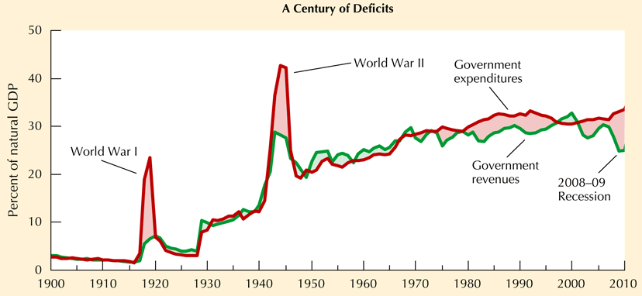

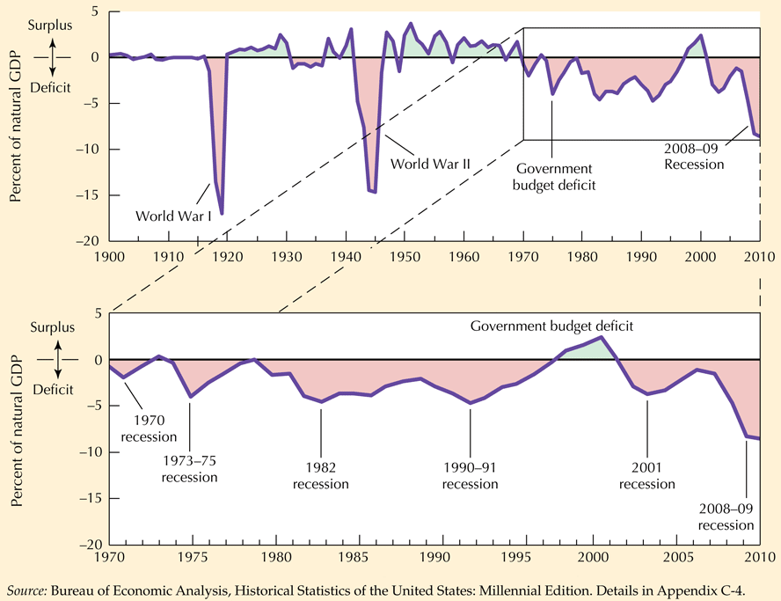

The above graph shows the historical record.

If the tax revenue is fixed, them if G increases then  must decrease (implies a job loss) or  must increase. This is an accounting identify!



The budget surplus is . It can change due to government policy that changes *G* or T or due to automatic stabilization or changes in *Y.*

How much of a deficit is not sustainable? Want to keep the debt to GDP ratio constant or D/PY = fixed. Define *d* = growth rate of debt, growth rate in nominal GDP = *p+y.* The growth rate of D/PY = . . Since in late 2010 government debt is 9,000 billion. Nominal GDP assumed to grow by 5%. Actual deficit much higher than 450 billion. => debt to nominal GDP ratio increasing as shown in graphs.

Fiscal policy can be used if monetary policy has lowered the interest rate to near 0.0.

TARP program helped avoid a worse problem BUT bailed out firms and their executives that were a source of the problem.

Obama fiscal policy had a low impact due to low multipliers for projects funded and the fact that it took a long time to roll out projects.

# Unemployment job Creation and Job Destruction

Unemployment rate measures the % of the labor force that is looking for a job but is unable to find one. Unemployment measured in a national survey of households. In a recession, unemployment can hit 10%. In the 30’s the rate was 25%. This was quite serious since there were fewer two wage earner families. If workers get discouraged they will stop searching and be not counted as unemployed

b = job losing rate or the ratio of the number of people that become unemployed in the labor force for that month.

e = job finding rate or fraction of unemployed who leave unemployment

u = unemployment rate or fraction of labor force that is unemployed

b = e * u

u = b/e or unemployment rate is ratio of job losing to job finding

* In 1967 to 1993 job losing (b) was 2.7%, job finding was 43% which imply rate of unemployment u of 6.3 (.027/.43 = .062791). This suggests a natural rate of unemployment of 6.4%. Some economists think this has fallen to 5.5% in the 90’s.
* **Flows into unemployment** due to: 1. Job destruction (in 1972-88 2% of manufacturing jobs were destroyed), 2. Job loss without destruction (Currently 5% per month) and 3. Personal transitions (Student changes jobs after graduation. Only 13% of unemployment rate due to this cause).
* **Flows out of unemployment** due to 1. Successful job search (66% of cases), 2. Desire to leave labor force (33%).
* **Search Theory**. Workers optimally would not take first job that comes along. If all jobs are the same worker takes first one offered. If there is a probability that a better job will come along, job seeker may wait.
* About 43% of unemployed either find jobs or leave the labor force. Natural unemployment rate = (job losing rate)/job finding rate) = b/e. ”Efficient wage view” holds that employment relation ship works best when workers feel their current jobs are valuable and that many are applying for their jobs and if they leave it will be hard to get a new job. Figure 5.1 shows this is associated in equilibrium with high unemployment.
* Unions raise wages and working conditions. This implies a higher rate natural rate of unemployment.
* Minimum wages raise natural rate of unemployment.
* Requiring those on welfare to seek jobs lowers the natural rate on unemployment.
* Figure 5.2 shows pattern of unemployment since 50’s. Figure 5.3 shows job destruction (which is positively associated with recessions).
* **Okun’s Law** for each percentage point that unemployment is above natural rate, real GDP is 3% lower than potential GDP.
* **Recessions allow firms to prune their operations**. Capital is recycled. HHS found that in Chicago in recessions there was more labor hoarding that is Detroit.
* **Phillips Curve** suggests that there is a negative tradeoff between unemployment and inflation. The argument was that to get lower unemployment there had to be higher inflation. Friedman and others suggested that this assumed that the workers were “fooled” into taking a job. Once they realized that the real wage was not as high (due to the inflation) they would not take the job. The Phillips curve did not explain “stagflation” or high inflation and high unemployment. (See section 8.2)

**Discussion**:

Effects of a ban on use of farm equipment:

On real wage. Since real wages track labor productivity, real wage will fall since less capital used in farming. Less capital implies less labor productivity.

On employment. Employment will increase to satisfy the demand to produce. More workers needed since less productive.

Unemployment. Unemployment will fall.

Labor productivity. Labor productivity will fall.

Discuss Analytical Problem 1 page 141

Natural unemployment rate = (job-losing rate)/(job finding rate) = (b/e).

1. No change
2. Natural rate of unemployment down due to students out of labor force e up.
3. Search costs down implies e up natural rate down.
4. Down due to e up.
5. Natural rate down since there is an incentive to take a job now rather than wait.

**Foreign Trade and the Exchange Rate**

* When imports > exports US must finance difference plus any other expenditures abroad with borrowing.
* **Terms of trade** = price of exports / price of imports.
* **Exchange rate** = $ price of one unit of foreign currency is usual definition. Book uses foreign currency price of one US dollar. Using book definition appreciation means exchange rate rises.

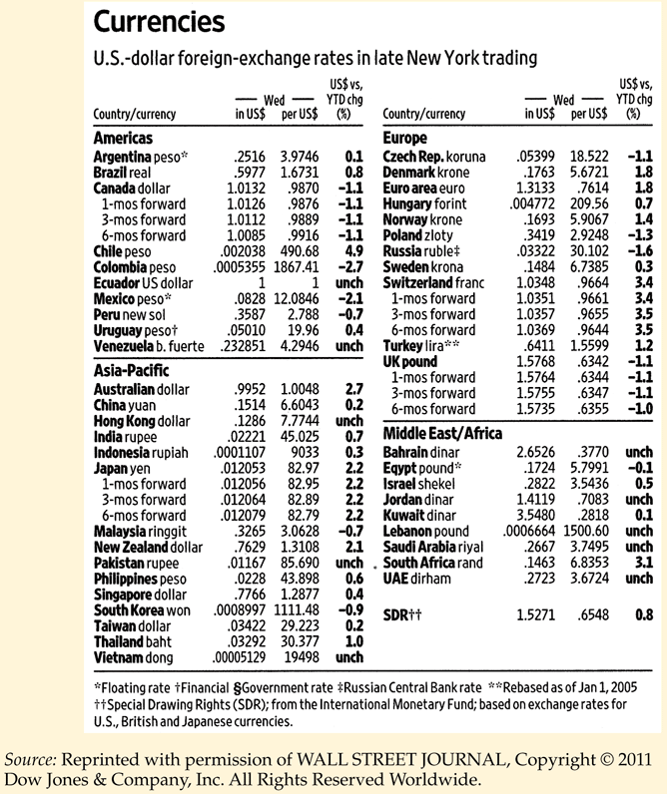

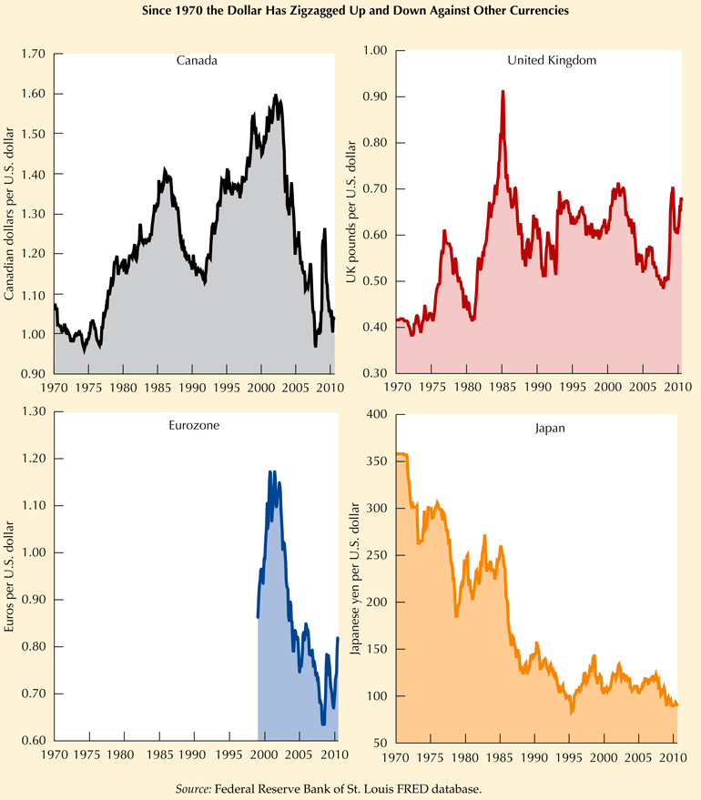

1A = 2B

2B =4C

* 1A=4C

A:B=.5

B:C=.5 => C:B=2

A:C=.25

If 1A = 4.1C go A to C (hold back .1 C and then to B. Gain .1 C!

A:B=A:C * C:B

Space arbitrage!

* **Real exchange rate** is an exchange rate adjusted for differences in price levels between US and rest of world. (ROW)= foreign price of US goods/foreign price of ROW goods.
* **Nominal exchange rate** = number of units of the foreign exchange rate per 1 US dollar.
* When real exchange rate is high foreigners have to pay more for goods produced in the US.
* **Purchasing power parity** => exchange rates move in step with prices of traded goods in different countries. Does not work in the short run but underlies long run adjustment dynamics.
* The real exchange rate (RE) is positively related to the US interest rate. High US interest rates attract capital into the US and appreciates the exchange rate.
* Open economy IS curve:



* Shows that the interest rate is negatively related to the real exchange rate. Appreciation of the dollar shifts the IS curve downward; depreciation raises the curve.
* M up => interest down=> I up => depreciate exchange rate => net exports rise. However the increase in GDP tends to decrease net exports because imports rise.
* Government runs a deficit due to tax cut => IS shifts outward, interest rates rise, and the dollar appreciates and net exports decline. This happened in the 80's.
* Fixed exchange rates and perfect capital mobility => monetary policy can inflate the world but have no effect on the domestic interest rate.
* Flexible exchange rates allow the monetary authorities to establish an interest rate different from the rest of the world.
* Price level adjusts quickly to events outside the country, especially if the home country is small.
* Movements in the exchange rate implicitly change prices in the home country.
* Recently there has been a trend toward trade liberalization (NAFTA and GATT).
* **Free Trade Area** => no tariff between countries who maintain their own tariff rates on third party countries. British Commonwealth of Nations
* **Customs Union=>**  Common tariff on third party countries.
* **Economic Union** => Customs union with labor mobile.
* **Monetary Union**=> Economic Union with a common money (US, EU)

**Gains from Trade** arise due to differences in technology and production conditions across countries.

- Ricardo stated that absolute advantage was not a necessary condition for trade. Trade could occur due to comparative advantage. Ricardo's example involved the number of hours to produce two goods:

Cloth Wine

Portugal 90 80

England 100 120

Portugal has absolute advantage in both goods since it takes less labor to produce cloth and wine than England. This does not mean that England cannot benefit from trade

In Portugal 90 hours of labor get you 9/8 of a wine barrel or 1C = (9/8)W.

In England 100 hours of labor get you 5/6 of a wine barrel or 1C = (5/6)W.

=> Portugal sell wine, England sell cloth which suggests that it would be desirable for labor in Portugal (England) to move into production of wine (cloth).

Basic graph showing gains from trade. Note consumption gain and production gain. To get production gain

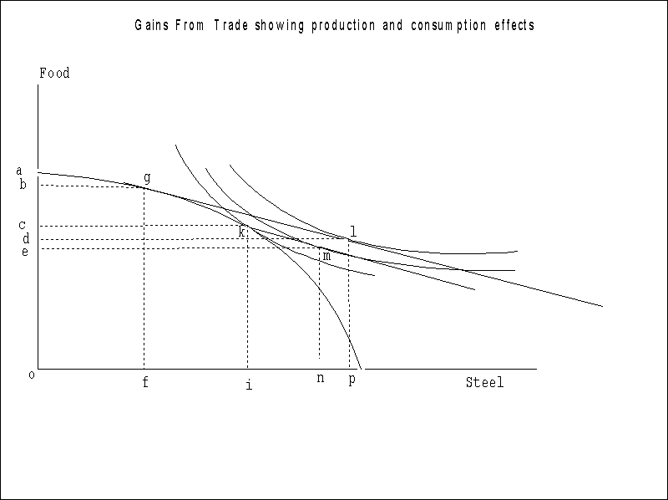

Problem 1:

Y = C + I + G + X

C = 220 + .63Y

I = 400 - 2000R + .1Y

M = (.1583Y - 1000R)P

X = 600 -.1Y -100 EP/Pw

EP/Pw = .75 + 5R

G=1200

Money supply = 900

Rest of world price and US price = 1.0

What is exogenous? endogenous?

Endogenous Y, C, I, X, R, E

Exogenous G, M, P, Pw

Problem 2. What is Y, R, C, I X, E predicted by model?

Y =220+.63Y+400-2000R+.1Y+G+[600-.1Y-(100(.75+5R))]

= 1145 + .63Y - 2500R + G

=> R = .458 - .000148Y + .0004G

From LM M/P - .1583Y = -1000R

=> R = .0001583Y - .001M/P

Equate R from the two equations

.458 - .000148Y + .0004G = .0001583Y - .001M/P

=> Y = 1495.266079 + 1.305909239G + 3.264773098M/P

Given G = 1200, M=900 and P = 1

Y = 1495.266079 + 1567.091087 + 2938.295788 =6000.65295

C = 220 + .63*6000.65295 = 4000.41136

R = .458 - .000148*6000.65295 + .0004*1200 = .049903363

I = 400 - 2000*.049903363 + .1*6000.65295 = 900.2585690

X = 600 - .1*6000.65295- 100(.75+5*.049903363)= -100.016978

E = .75 + 5*.049903363 = .999516815

Traded goods determine the exchange rate. Capital flows also have an effect.

Trilemma => The impossibility for any nation of maintaining simultaneously:

1. Independent control of monetary policy.

2. fixed exchange rates and

3. free flows of capital with other nations.

At issue is over what area should be have fixed exchange rates? Mundell – Optimum Currency areas. Is the EU an optimum currency area? What does Greece feel? What does Germany feel?

fixed real exchange rate = nominal exchange rate * ratio domestic P to foreign price.

Note: **Gordon uses foreign price of one unit of domestic currency in places!**

**Given this definition!**

Growth rate of nominal exchange rate = growth rate of foreign price level – growth rate of domestic price level.

Table 7-2 show forward exchange rates. Assume a trader has to pay for UK goods in three months. Looking at the UK and using the American notation ($ price of the pound)" three months in the future, if one expects the exchange rate of the UK pound to appreciate from its current $1.5768 value, then

. Since the 3 month forward rate is $1.5755 if sufficient pounds are purchased at this rate the trader will hedge himself/herself against exchange risk without having to buy pounds now at the current spot rate of $1.5768.

Forward covering can be used to arbitrage interest rates in the US and the UK. Assume  are the three month interest rates in the US and UK. The equilibrium relationship between forward rate today for 3 months in the future  and the spot rate today is

.

 implies an inflow

 implies an outflow.

The above analysis suggests that if the Federal Reserve increases *F* it will stimulate an outflow!

**Aggregate Demand, Aggregate Supply and the Great Depression**

Want to link the IS/LM curve intersection with the aggregate demand and aggregate supply curve.

**Aggregate Demand Curve**  Shows locus of points showing combination of the price level and real output at which the money and commodity markets are in equilibrium. **The AD curve by itself cannot determine two unknows: real GNP and the price level.**

**Short Run Aggregate Supply Curve.** Shows amount of output business firms are willing to produce at different price levels holding constant the nominal wage rate. The short run aggregate supply curve (SAS) shows the amount of output that business firms are willing to produce at different price levels, holding constant the nominal wage. Assuming wages and other input costs are fixed. higher product price + fixed input costs => higher profits => higher output.

SAS moves up if nominal wage increases.

Long Run Aggregate Supply Curve shows amount of out business firms willing to supply when nominal wages are fully adjusted to any change in prices.

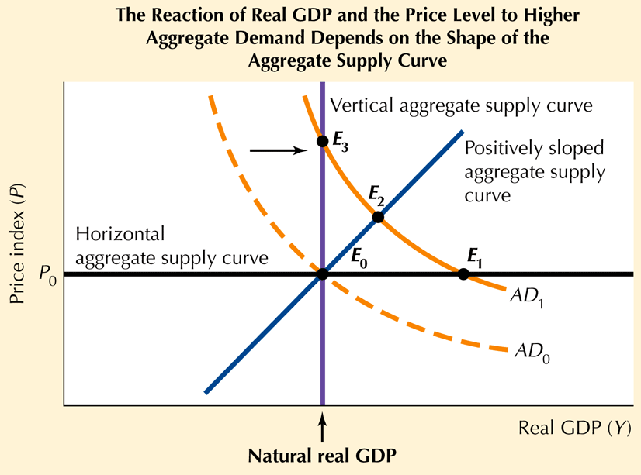

Figure 8-1. Decline in P moves us down AD curve. Does not shift the curve! Any shift up for C+I+G+NX will move the IS curve and the AD curve to the right

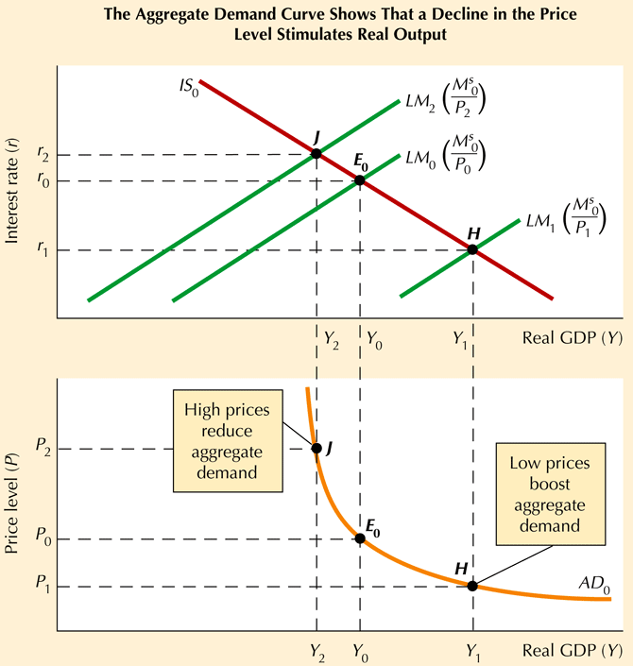

A boost in M moves the LM right and the AD curve right.

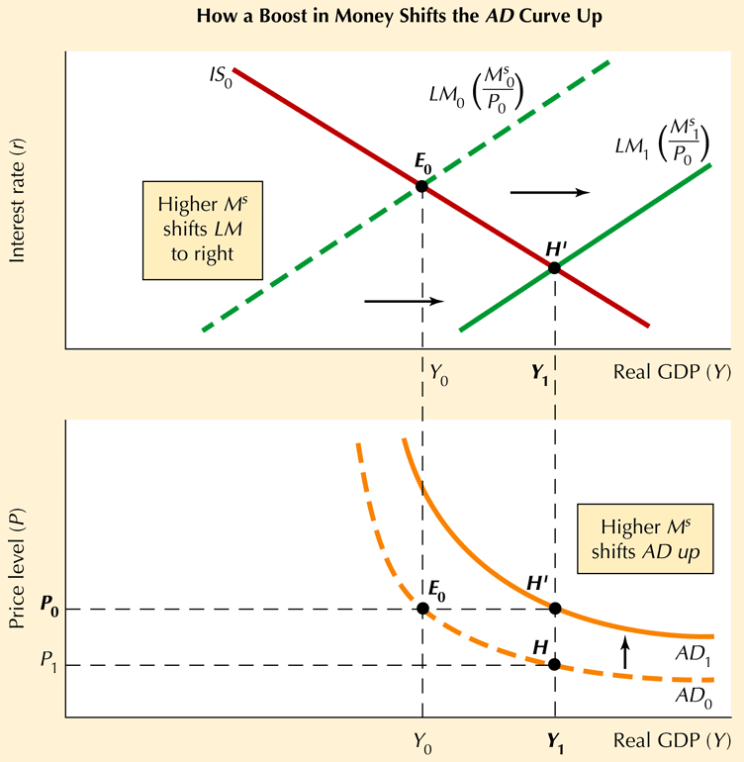

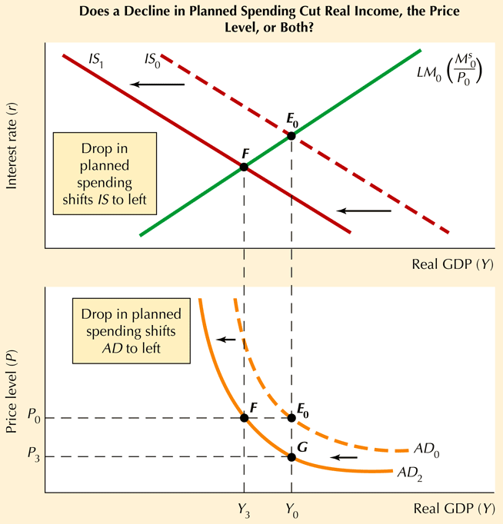

The effect depends on the shape of the AS curve. If the AS curve is vertical, only price decreases. If it is horizontal, then only output decreases. If the AS curve is positively sloped then both real income and price decrease.

Along any AS curve the nominal wage is fixed, prices of inputs are fixed and the level of productivity and technology is fixed..

i LM

Ms > Md Ms < Md

Y/p

* **IS-LM analysis** developed by J. R. Hicks to explain Keynes. IS-LM model is a key engine of analysis that can be used to illustrate at least “first round” effects. To get insight into more than first round effects a model is needed. To obtain quantitative numbers for the effects, we need to obtain estimates of the parameters of the equations underlying the IS-LM equations.

i

I < S I > S

IS

Y/P

LM LM*

i

b

a d

c

IS IS*

Y/P

Start at a. If M ↑ => LM to LM* and a movement to c.

Start at a. If T ↓ or G ↑ => IS to IS* and a movement to b.

Which point is better for banks? For you?

If both M ↑ and G ↑ or T ↓ => movement to d.

**Advanced concepts**. We have drawn the LM and IS in terms of i and Y on the axis. Can derive these curves assuming other variables. For this section =domestic price of one unit of the foreign currency.



The usual LM sets all partials except = 0.

Assume  on vertical axis and on horizontal axis => LM curve goes from upper left to lower right.



General IS curve model.





**Chapter 9. Inflation: Its Causes and Cures**

Core Inflation = inflation rate for all products other than food and energy.

**Demand Pull Inflation** is due to a continuous increase in demand due to government deficits or increases in money supply.

Basic equation MV=PT where M = monetary base, V = velocity, P =price level and T = real GNP transactions. Book shows  where *Y* = nominal GNP.

In the current period (2014) the monetary base is high but velocity is at a record low level. As of June 2014 inflation has not been a problem, although some economists such as Feldstein are concerned over the long run. The danger is that if velocity should increase, the Federal Reserve would have to reduce the monetary base quickly without driving the economy into recession.

At issue is whether velocity is fixed. While the Keynesian economists in the 30’s argued that the money demand function was not stable due to changes in velocity that could not be anticipated, Friedman argued that velocity was relatively stable and that if the rate of monetary growth was announced and proportionate to the rate of growth, the economy would be stable.

In the 30’s the mistake was made by using the interest rate as a gage of whether there was too much or too little money. Interest pegging worked as follows. If the market rate of interest was below the interest rate target, then using increases in reserve requirements or the sale of bonds to reduce the money supply could be used to raise the interest rate. The problem is that if the interest rate target is too high, the Fed will be putting the breaks on the economy just when the reverse was needed.

Since 2008 the interest rate has been driven to record lows. Bernanke vowed to not let the experience of the 30’s happen again. Quantitative easing has been implemented to give the banks reserves which they can use the make loans. But will they?

What has not been resolved is how to get this liquidity out of the system when inflation starts to be a problem.

In the short run the price level is predetermined. The AD curve shifts due to ΔT, ΔG or ΔM. If the resulting income level is above (below) the level of potential income price will increase (decrease) in subsequent periods. This analysis abstracts from expectations effects.

Okun's law states that for each percentage point by which the unemployment rate is above the natural rate, real GDP is 3 percent below potential GDP (). This is a "quick and dirty" rule to follow. It does not give perfect forecasts.

If GDP is < potential GDP it is possible to determine the unemployment rate using Okun's law.

measures the pressure on prices to adjust. Inflationary momentum is an added effect.

**Phillips curve**. Define π = inflation = , πe = expected inflation.



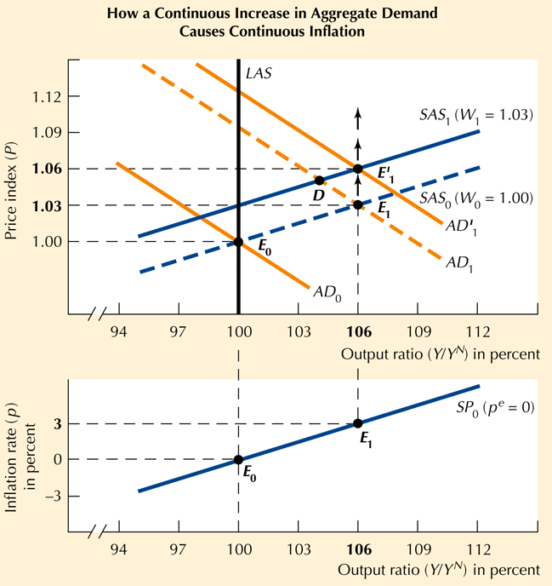

AD curve shifts right which increases the output ratio **until people catch on to what has happened** and shift the SAS curve up. The shift upward will in turn shift the short run Phillips curve upward.

**Natural rate property**. Since actual GDP can only exceed potential GDP if actual inflation exceeds expected inflation, this implies that there is no way for GDP to be above its natural rate without inflation (not just prices) increasing. This was first discovered by Phelps and independently by Friedman. The implication of this analysis is that the government cannot fool the people in the long run. This analysis was developed during the stagflation period when the US economy had high inflation and high unemployment.

If we assume that ,, the Phillips curve becomes



This implies that under conditions of expected inflation the price adjustment relation is shifted upward by the amount of the expected inflation. Hence only in the short run when inflation expectations are catching up can output be above potential output. The mechanism is that in this situation workers are fooled into working longer since they see their real wages as higher than they actually are.

**Forward-looking expectations** attempt to predict the future behavior of an economic variable.

**Backward-looking expectations** use only information from the past to make future predictions.

**Overshooting.** The economy is first at potential GDP. Next M up causes . Define  as inflation. Since backward looking expectations have not caught up, initially . Then as price expectations increase,  falls to a value below . => In the long run an increase in M does not lead to an increase in Y.

Problem  = 3401 + 2.887*( M/P)

πt = .6*πt-1 + 1.2*[( - 6000)/6000]

P = 1 (initially)

M=$850

 =6000.

For what value of M/P will GNP = potential GNP? If the money supply is fixed, what will happen to the price level? Who gains debtors or creditors?

6000 = 3401 + 2.887*(M/P)

M = (6000-3401)/2.887 = 900.24

Equilibrium P = 850/900.24=.94418

Using the simplified model

C = 220 + .63*Y

R = ((M/P)-.1583*Y)/-1000

I = 1000 – 2000*R

X = 525 - .1*Y – 500*R

what happens to the interest rate, consumption, investment and net exports over the next 30 years?

The file overshooting.xlsx can be used to solve this problem.

|  |  |  |  |  |  |  |  |  |
| --- | --- | --- | --- | --- | --- | --- | --- | --- |
| Overshooting Example |  |  |  |  |  |  |  |  |
|  |  |  |  |  |  |  |  |  |
| Model Givens |  |  |  |  |  |  |  |  |
| Y=3401+2.887*(M/P) |  |  |  |  |  |  |  |  |
| inf=.6*inv(t-1)+1.2*((yt-1-6000)/6000) | |  |  |  |  |  |  |  |
| C=220 + .63Y |  |  |  |  |  |  |  |  |
| R=((M/P)-.1583*Y)/(-1000) |  |  |  |  |  |  |  |  |
| I=1000-2000R |  |  |  |  |  |  |  |  |
| X=525-.1*Y-500*R |  | Defaults |  |  |  |  |  |  |
| ycoef1 | 3401 | 3401 |  |  |  |  |  |  |
| ycoef2 | 2.887 | 2.887 |  |  |  |  |  |  |
| Inflation coef1 | 0.6 | 0.6 |  |  |  |  |  |  |
| inflation coef2 | 1.2 | 1.2 |  |  |  |  |  |  |
| Full employment | 6000 | 6000 |  |  |  |  |  |  |
| ccoef1 | 220 | 220 |  |  |  |  |  |  |
| ccoef2 | 0.63 | 0.63 |  |  |  |  |  |  |
| rcoef1 | -0.1583 | -0.1583 |  |  |  |  |  |  |
| rcoef2 | -1000 | -1000 |  |  |  |  |  |  |
| icoef1 | 1000 | 1000 |  |  |  |  |  |  |
| icoef2 | -2000 | -2000 |  |  |  |  |  |  |
| xcoef1 | 525 | 525 |  |  |  |  |  |  |
| xcoef2 | -0.1 | -0.1 |  |  |  |  |  |  |
| xcoef3 | -500 | -500 |  |  |  |  |  |  |
| M | 850 | 850 |  |  |  |  |  |  |
| initial P | 1 | 1 |  |  |  |  |  |  |
| initial inflation | 0 | 0 |  |  |  |  |  |  |
|  |  |  |  |  |  |  |  |  |

|  |  |  |  |  |  |  |  |  |
| --- | --- | --- | --- | --- | --- | --- | --- | --- |
| Solution |  |  |  |  |  |  |  |  |

YEAR Y INF P R C INV X TEST

**** ****** ********** ******* ******* ****** ****** ******** ******

0 5855 0 1 .076839 3908.6 846.32 98.914 4656

1 5928.3 .02901 .97099 .063049 3954.8 873.9 99.351 4729.4

2 6011.1 .031753 .94016 .047461 4007 905.08 99.845 4812.3

3 6055.8 .016823 .92434 .039061 4035.2 921.88 100.11 4856.9

4 6053 .0010677 .92533 .039594 4033.4 920.81 100.09 4854.1

5 6023.5 .011236 .93573 .045136 4014.8 909.73 99.919 4824.6

6 5993.8 .011443 .94643 .050716 3996.1 898.57 99.742 4794.9

7 5979.3 .0056337 .95177 .053448 3987 893.1 99.655 4780.4

8 5981.3 7.5707E 4 .95105 .053081 3988.2 893.84 99.667 4782.4

9 5992.2 .0042009 .94705 .051034 3995.1 897.93 99.732 4793.3

10 6002.8 .0040901 .94318 .049032 4001.8 901.94 99.795 4803.9

11 6007.7 .0018953 .94139 .048103 4004.9 903.79 99.825 4808.8

12 6006.7 4.0965E 4 .94177 .048304 4004.2 903.39 99.819 4807.8

13 6002.6 .0015792 .94326 .049076 4001.6 901.85 99.794 4803.7

14 5998.8 .0014592 .94464 .049789 3999.2 900.42 99.771 4799.9

15 5997.1 6.2911E-4 .94523 .050096 3998.2 899.81 99.762 4798.2

16 5997.6 1.9561E-4 .94505 .050001 3998.5 900 99.765 4798.7

17 5999.2 5.8885E-4 .94449 .049713 3999.5 900.57 99.774 4800.3

18 6000.5 5.1881E-4 .944 .04946 4000.3 901.08 99.782 4801.6

19 6001.1 2.0705E-4 .94381 .049358 4000.7 901.28 99.785 4802.2

20 6000.8 8.7671E-5 .94389 .049401 4000.5 901.2 99.784 4801.9

21 6000.3 2.1892E-4 .94409 .049508 4000.2 900.98 99.78 4801.4

22 5999.8 1.8386E-4 .94427 .049598 3999.9 900.8 99.777 4800.9

23 5999.6 6.7265E-5 .94433 .049631 3999.8 900.74 99.776 4800.7

24 5999.7 3.7653E-5 .9443 .049612 3999.8 900.78 99.777 4800.8

25 5999.9 8.1034E-5 .94422 .049573 3999.9 900.85 99.778 4801

26 6000.1 6.4942E-5 .94416 .049541 4000.1 900.92 99.779 4801.2

27 6000.1 2.1529E-5 .94414 .049531 4000.1 900.94 99.78 4801.2

28 6000.1 1.571E-5 .94415 .049538 4000.1 900.92 99.779 4801.2

29 6000 2.9887E-5 .94418 .049553 4000 900.89 99.779 4801.1

In long run Y = 6000, π = 0.0, P = .94418, R = .049553, C = 4000, I= 900.89, and X=-99.779.

Since C depends on only Y, when Y overshoots, C will overshoot. I depends only on R. I will overshoot when R is low. I overshooting will push up Y. X depends on both Y and R and does not have this pattern.

Assume that a serious shock to potential output occurs and it falls to 5000. Resolve the model using overshooting.xlsx. (During the Black Death in 1347 1/3 of the people in Europe died. What do you think happened to prices?) Report your findings and discuss what you have found and why.

Finally assume that the economic situation after the Civil War in 1865 is repeated. Remember in that period there was growth with a fixed money supply!

If there is a sudden and permanent decline in potential GDP then initially there is no effect. Since  . As prices rise, *R* will increase while investment and consumption fall. The effect on net exports is unclear since  up =>  down (due to increased imports and possibly a fall in exports at the exchange rate appreciates) yet *R* up => *X* up due to capital being attracted. The economy might proceed to a new equilibrium or cycle as it proceeds to the new equilibrium depending on inflation expectations.

**Chapter 10 Goals of Stabilization Policy: Low Inflation and low unemployment**

* **Two types of shocks can hit the economy**.
* An **aggregate demand shocks** is some event other than a policy change that shifts the aggregate demand curve. Examples include changes in foreign demand changing net exports, or a new type of credit card that impacts money demand.
* A **price disturbance** is some event that shifts the price adjustment relationship.
* Disturbances can be temporary or permanent.
* Since monetary and fiscal policy also shift the aggregate demand curve, in order to determine the effect of a shock we have to know what will be the change in monetary and fiscal policy.
* **Price level shocks**. Oil cartel; Firms make a mistake on expectations and increase prices; Union gets an excessive settlement.
* **Economic Shocks**. Investment function intercept changes. Change in money demand for a given level of income or interest rate.
* While most economists agree on the desirability of maintaining aggregate demand, there is disagreement on the means by which this is done. Disagreements center on:

The effectiveness of a governmental policy especially in a world of changing expectations, the difficulty at predicting when a policy is needed (recognition lag) and problems in implementing the policy in a timely manner (implementation lag).

* Monetarists agree that monetary policy has an effect on real variables in the short run. In the long run prices adjust and the effect wears off. The problem is the monetary policy occurs with a long and variable lag.
* Politics. Monetary policy can lead to inflation, especially when monetary policy decisions are made in a political setting.
* Assume an upward price shock. Policies that increase the money supply in response to a price shock are called accommodative policies. These put less pressure on prices to fall than nonaccommodative policies that hold the money supply fixed and put maximum pressure on prices to fall.
* While treating policy variables as exogenous has long been the tradition, another view would treat them as endogenous or the function of some policy rule.
* There is a controversy over how much cost is incurred by not smoothing out the cycle. Tobin & Okun stress that the costs are larger than Lucas and others. A recession may have the benefit of making firms leaner, however. There is no comparable mechanism for the public sector.
* By the selecting the policy mix the Fed can control the position and the slope of the AD curve.
* Recent research has stressed that for a policy to be effective it must be consistent and credible. The Budget Enforcement act of 1990 provides that every increase is entitlement spending must be matched by either a decrease in other entitlement spending or increased taxes. Explicit dollar limits were placed on discretionary spending for 5 years.
* In recent years the Federal Reserve has concentrated on policy rules not exogenous changes in the policy instruments. Reasons include:
* 1. The recognition that expectations of policy can influence how policy works
* 2. The desire that policy not be time inconsistent, i. e. over time policy makers will do what they said they would.
* If Phillips relationship was π = πe + f((Yt-1 - Y*)/Y*), then the only way that a policy maker could obtain disinflation would be to have Y fall below potential output. If this is case, then the Fed must first determine the target level of Y below Y*. The appropriate amount of money supply needed to achieve this goal can be obtained from the LM equation. The more Y is less than Y* the faster the price level falls.
* Sargent studied hyperinflation and concluded that it did not require Y to be substantially less than Y* for a long period to curtail inflation. The key was the perception that a policy change had occurred.

**Four conditions that are necessary for inflation to be harmless**

1. Inflation is universally and accurately anticipated
2. An increase in the expected inflation rate raises the market nominal interest rate (i) for both savings and borrowing by exactly the same number of percentage points.
3. All savings are held in bonds, stocks or savings accounts earning the nominal interest rate; No one holds money in accounts with an interest rate below the market interest rate.
4. Only the real (not the nominal ) interest rate is taxable, and only the real cost of borrowing is tax deductible.

# 1 Borrowers gain from surprise inflation.

# 2  => Fisher equation predicts countries with rapid inflation will have high nominal interest

rates.

# 3 Money does not pay interest. => Holders of money suffer losses if there is inflation.

# 4 Indexation (such as IRS tax code) reduces cost of inflation.

Problem 1

Y = C + I + G + X

C = 220 + .63Y

I = 1000 - 2000R

X = 525 - .1Y - 500R

M = (.1583Y - 1000R)P

π = 1.2((Yt-1 - 6000)/6000)

M = 900, G = 1200, Y = 6000, P = 1

Money supply = $900, G=1200, Output at potential of 6000, P=1. In year of shock new money demand function is M = (.1583Y - 2000R)P. Price initially will not change. Real money stays at 900/1 = 900.

We derive the IS and LM curves and solve for the initial R and Y.

Y = C + I + G + X

= 220 + .63Y + 1000 - 2000R + G + 525 -.1Y - 500R

= 1745 - 2500R + .53Y + G

R = (1745 - .47Y + G)/2500

1.497286169*1200= .6980 - .000188Y + .0004G

From new LM

R = (.1583Y - (M/P))/2000

= .00007915Y -.0005M/P

Equate to form equation for AD curve

.6980 - .000188Y + .0004G = .00007915Y - .0005M/P

.6980 - .00026715Y + .0004G =-.0005M/P

Y = (-.0004G - .0005M/P -.6980)/(-.00026715)

Y = 2612.764365 + 1.497286169G + 1.871607711M/P

When M=900, P= 1, G=1200 =>

Y = 2612.764365 + 1796.743403 + 1684.446940 = 6093.954708

R = .00007915*6093.954708 - .0005*900 = .03203

=> Monetary shock raised Y and R

In subsequent years Y will fall back to 6000 and P will rise to solve the new AD curve.

6000=2612.764365 + 1.497286169*1200 + 1.87160771*900/P

6000 - 2612.764365 - 1796.743403 = 1684.446930/P

P = 1684.446930/1590.492232 = 1.059072717

R for long run Y=6000 calculated from new LM equation

R = .00007915*6000 - .0005*900/1.059072717 = .04999999

The Fed could have reduced the money supply at once to maintain the same real money supply. The correct money supply would be (900/1.05072717) = 856.54

**11-12. Theory of Economic Growth**

Lucas commenting on growth “the consequences for human welfare are simply staggering. Once one starts to thinking about them, it is hard to think of anything else.”

$45,000 in 2010. At 2 % in 50 years it grows to $122,300. If growth was 2.5% $157,100.

Since WW II a formerly poor country like South Korea joined the richer countries while the Philippines has not gained. Within a rich country like the US and Europe, inequality has become a problem. What are some of the reasons this has occurred?

In 1870 UK average GNP person was 32% higher than US. By 1906 the US caught up. By 2010 the US is 32% ahead although after 1950 the UK has kept pace with the US. Note the effect of war on growth!

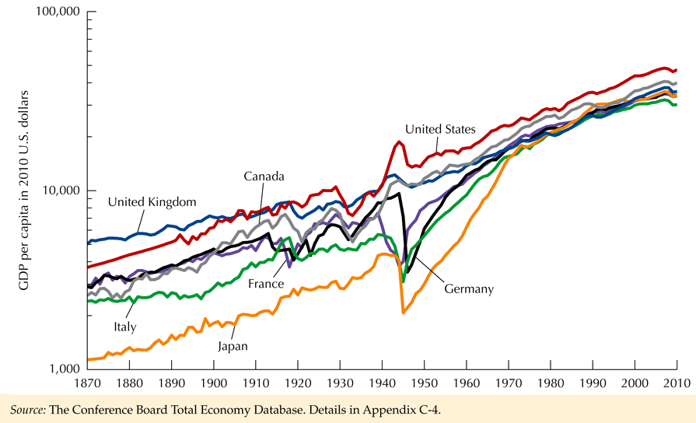

* Determinants of long run growth are labor, capital, and technology.
* Since Civil war growth in South .5% greater than in North.
* At time of Civil War per capita income in South 40% of North. Now it is about even. If growth in the 70's and 80's in the US had been what it was in the 50's and 60's => production in US up $4000 per capita or about 3 times national defense budget. Growth matters.
* Labor increased in 70's and 80's, will slow in the years ahead as the country gets older. Countries in Europe has birthrates that do
* Labor participation rate has first increased. (Role of women in labor force since WWII). Since 2007 crisis, labor participation rate has fallen.
* The natural rate of unemployment is about 5-6%, part is due to frictional unemployment. A small group of individuals accounts for the majority of the unemployment. The natural rate of unemployment can change over time due to changing characteristics of the labor force. Older workers typically have less unemployment. Young workers, especially those with poor education, also are negatively impacted.
* If net investment > 0 => the capital stock will increase.
* Difficult to measure capital utilization rate. Can use max electric power generation or (1-u) where u = rate of unemployment. Why is measuring capital utilization rate so important? Unless be know this value we do not know if the economy is getting “over heated.” An over heated economy => potential for inflation since an increase in demand cannot be met by an increase in supply. Under what conditions can this occur? (Wars (demand shocks). Oil crisis (supply shock).
* Mass production is a technological advance. Modern factories that allow quick change-overs from one good to another are an example of technology.
* Technological change increases total factor productivity.
* Production function Y = F(N, K, A)
* N = Labor, K = capital and A = technology.
* Cobb-Douglas form Y = AeΛtNαKβ
* Marginal product of labor = dY/dN = αAeΛtNα-1Kβ = αY/N
* Marginal product of capital = dY/dK = βAeΛtNαKβ-1 = βY/K

From the marginal product equation we note that:

ηk  = β and ηl = α

(β + α) is greater (less) that one, when there is increasing (decreasing) returns to scale.

* Figure 11-1 shows output per unit of labor as a function of K/N given other inputs. The shape is due to diminishing marginal product of capital. Contrast “diminishing marginal product of capital” with “diminishing returns to scale.”
* Demand for Labor. In equilibrium marginal product of labor = real wage.
* If wages increase => wage bill equation will be steeper and max profit position will be where there is less labor. The analysis assumes that the other factors are fixed. If the other factors are not fixed, what will happen?
* Marginal product schedule => demand for labor function where employment is a negative function of the real wage. What assumptions have to be made to draw this curve?
* The supply of labor is a positive function of the real wage. The supply of labor is effected by the substitution effect (as the real wage increases leisure time away from work gets more expensive) and the income effect (as income increases people everything else equal work less).
* Employment is where supply of labor = demand for labor. N* = full employment. Full employment is not max amount of work people would do, only what they would do for the level of the real wage prevailing. Define full employment as Y* where

Y* = f(N*,K,A)

where A = technology. Another approach would put the technology directly in the labor (N) and capital (K) measure.

* Balanced growth => rate of growth of capital = rate of growth of labor.
* Solow model has n = rate of growth of labor
* Net investment = nK= I-dK. Where d is depreciation rate.
* Given s = savings rate, net saving = sY
* Balanced growth => sY = nK or K/Y = s/n
* Capital output ratio = ratio of savings rate to rate of growth of labor force.
* What happens if sY > nK? = > capital grows, MPPk = Mk falls as K /Y increases. More capital is needed for each unit of output.
* The growth rate depends on growth of labor (capital) not the savings rate.
* What is the effect of increasing savings rate. Steady state point is where savings is just enough to keep capital per worker constant.
* During old growth path, growth = growth of labor. Then savings rate increased making s/n > K/Y. As K/Y increased growth was faster until in equilibrium it slowed to again equal the rate of growth of labor.
* Technological change => workers get more productive by factor g. Now capital must increase by n+g or

K/Y = s/(n+g)

* Growth = technology growth plus weighted growth of capital and labor. How does technology increase. The below equation postulates a production function for technology

ΔA = T(NA,KA,A)

or the increase in technology, ΔA , depends on the amount of labor producing technology NA and the amount of capital producing technology KA.

* Neutral technological change => F(N,K,A)=Af(N,k)
* ΔY/Y = ΔA/A + Δf(N,K)/f(N,K)
* Δf(N,K)/f(N,K) = MNΔN/Y + MkΔK/Y
* ΔY/Y = ΔA/A + MnΔN/Y + MkΔK/Y
* In equilibrium the marginal product of labor equals the real wage, Mn = W/P, and the marginal product of capital is the real rental price of capital, Mk = Rk / P (real wage & rental price of capital)
* ΔY/Y = ΔA/A + (W/P)ΔN/Y + (Rk/P)ΔK/Y
* ΔY/Y = ΔA/A + (WN/PY)ΔN/N + (RkK/PY)ΔK/K
* WN/PY = fraction of revenue paid out to labor assumed to be .7
* RkK/PY = fraction of revenue paid out to capital assumed to be .3
* Effect of technical change is less in 80's than in 60's. Effect of labor is greater. Is this correct? Will this continue? What long run implications does a lower role for technological change have?
* **The only need for governmental intervention is in cases of market failure.** Specific policies are investment tax credit and government support of research.
* Given RkK/PY ~ .3 => 3.3% growth of capital to increase output 1%. Growth in capital was at 7% in 1966, then went down. In 1994 it would have taken a 22% increase in the amount of investment to raise the capital stock by 3.3 percent. This rate of increase could not be sustained.
* Since WN/PY ~ .7 => growth of labor has 2 times the effect of growth of capital. Reductions in taxes stimulate work effort, increase employment via a shift in supply of labor schedule.
* The last 30 years have seen a marked slowdown in real wage growth, especially in the middle class. Causes include labor productivity slowdown. Total factor productivity is a general measure of productivity.
* Endogenous growth theory (Romer-Lucas-Arrow-Uzawa) stresses that capital, labor and technology are endogenous. Changes in taxes might have a permanent effect on the growth rate not just level as suggested by Solow.
* Most economists argue that potential GDP evolves smoothly over time. A recession or boom is a temporary departure from potential. The Real business cycle theory argues employment is always where supply = demand. Employment changes only when the supply or the demand curve shifts.

* In the post 2007 period young people were especially hit. The longer the period of unemployment the more the human capital of the unemployed workers is depreciated.
* An oil shock could shift the demand for labor down and cause the real wage to fall.
* The demand for labor is a function of the marginal product of labor. For farmers the marginal product shifts during different times of the year. The real business cycle theory suggests that these shocks are exogenous and cause business cycles.
* The real business cycle theory states that Δ productivity => Δ employment. Critics state that the causality goes in reverse due to "labor hoarding" in recessions when workers are kept on because they would be so hard to replace when the economy turns up.

Page 350 of Gordon discusses how the unemployment rate in Germany was substantially less than in the US after 2007. It appears that the German government encouraged German Industry, via payments, to reduce hours from 40 to 30 in a work sharing plan. This kept human capital from getting rusty. Down time was used for training and maintenance and allowed the firms to speed up production quickly as times got better. Stokes-Jones-Neuburger (1975) found that variability of hours was higher in Chicago than Detroit as firms in Chicago attempted to hang on to labor during down turns.

Supply

W/P

Demand

N* N

Y/P

Production Function

(Y/P)*

N* N

The Demand and Supply of Labor determine the full employment labor N* from which we get full employment (Y/P)*

Problem 1. Labor supply = labor demand

a. 1000 + 12 (W/P) = 2000 - 8 (W/P)

20 (W/P) = 1000, W/P = 50,

N = 1000 + 12 * 50 = 1600

b. Y = 100 N.5 => diminishing marginal product since

a 4 * increase in labor => output goes up 2 times

Y = 100 * 1600.5 = 4000

Problem 2

ΔY/Y = ΔA/A + .7ΔN/N + .3 ΔK/K

.05 = ΔA/A + .7*.02 + .3 * .04

ΔA/A = .024

If ΔK/K rises by .01 => ΔY/Y rises by .003=.01*.3

If ΔN/N rises by .01 => ΔY/Y rises by .007

Problem 3

Y = AN.7K.3 => lnY = lnA + .7 lnN + .3 lnK

Marginal product of capital = .3Y/K

Marginal product of labor = .7Y/N

Labor demand .7Y/L = W/P

Labor share = .7, Capital share = .3

Key concepts

Standard of Living = real output per capita

Labor productivity = Real output per hour

Solow Model: The reason that the Solow model suggests convergence is that it assumes unrealistically that all nations have the same per-person production function, savings rate, growth rate of the population and depreciation rate. It further assumes the rate of technical change is the same in all countries and that the best technology is freely available to all countries. The relationship between the investment rate (the share of investment in GDP) and the standard of living across many nations is weak.

T. W. Schultz (*Transforming Traditional Agriculture)*: Schultz was awarded the Nobel Prize for his work in [development economics](http://en.wikipedia.org/wiki/Development_economics), focusing on the [economics of agriculture](http://en.wikipedia.org/wiki/Agricultural_economics). He analyzed the role of agriculture within the economy, and his work has had far reaching implications on [industrialization](http://en.wikipedia.org/wiki/Industrialisation) policy, both in developing and developed nations. Schultz also promulgated the idea of [educational capital](http://en.wikipedia.org/wiki/Educational_capital), an offshoot of the concept of [human capital](http://en.wikipedia.org/wiki/Human_capital), relating specifically to the investments made in education.

Schultz researched into why post-World War II [Germany](http://en.wikipedia.org/wiki/Germany) and [Japan](http://en.wikipedia.org/wiki/Japan) recovered, at almost miraculous speeds from the widespread devastation. Contrast this with the [United Kingdom](http://en.wikipedia.org/wiki/United_Kingdom) which was still rationing food long after the war. His conclusion was that the speed of recovery was due to a healthy and highly educated population; education makes people productive and good healthcare keeps the education investment around and able to produce. One of his main contributions was later called [Human Capital Theory](http://en.wikipedia.org/wiki/Human_Capital_Theory), and inspired a lot of work in [international development](http://en.wikipedia.org/wiki/International_development) in the 1980s, motivating investments in vocational and technical education by [Bretton Woods system](http://en.wikipedia.org/wiki/Bretton_Woods_system) [International Financial Institutions](http://en.wikipedia.org/wiki/International_Financial_Institutions) such as the [International Monetary Fund](http://en.wikipedia.org/wiki/International_Monetary_Fund) and the [World Bank](http://en.wikipedia.org/wiki/World_Bank).

Sachs and others have stressed the negative effect of a country being landlocked and not having a stable political system together with a legal system that protects private property.

US Productivity has varied. Rapid until the 70’s. Causes include demographic changes (influx of less experienced workers with less human capital) and the fact that the growth of the capital stock slowed while the growth of the labor force increased.  Other factors include raw material and energy shocks. Infrastructure improvements such as interstate roads were completed which helped growth. The interstate system allowed workers to live outside cities and get to work. Productivity increased in the1995-2004 period due to computers. Layoffs in the period after 2000 raised productivity of remaining workers.

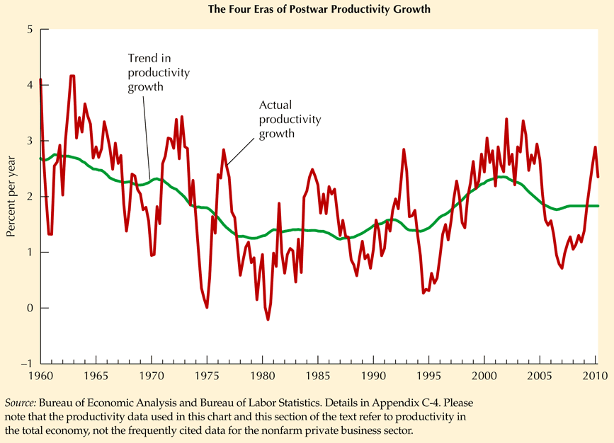

**13-14. Money, Banks and the Federal Reserve and a Brief Discussion of policy**

Elements of a Monetary system.

Historical notes: Before the creation of the Federal Reserve in 1913 the US economy was subject to monetary shocks due to gold discoveries (1849 Gold rush) and cash holding ratio and the reserve ratio fluctuated dramatically. The crime of 73 (1873) was in response to the refusal to coin silver to stem the fall of prices and was championed by the mid western and far western states which had a large percentage of debtors. The establishment of the Second Bank of the US in 1816 was due to the desire for a central bank that would insure that banks that issued bank notes would redeem in specie. In 1832, the renewal of the Second Bank of the US became an election issue between Jackson and Clay and as a result was not renewed in 1816.

* Money is used as **Means of payment, standard of differed payment**, and **unit of account**.
* What is money? How are payments made? Major changes!

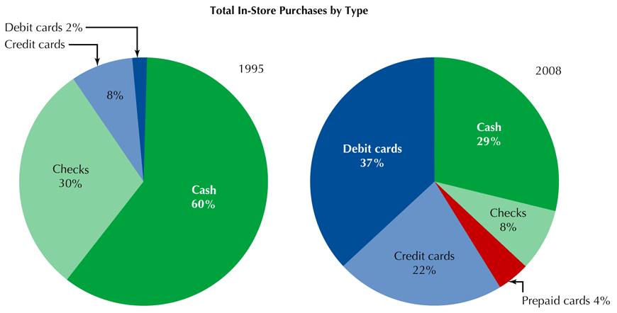

Note that the major increase is in debt cards not credit cards? Why?

* M1 = currency (c) + checking deposits (D)
* M2 = M1 + savings deposits + small time deposits + money market mutual funds + money market deposits at banks
* M3 = M2 + time deposits > 100,000
* Far more transactions made with credit cards than currency.
* Reserve requirements => reserves (RE) = rD where r is reserve ratio.
* Currency to deposit ratio (c) = CU/D
* Monetary base = high powered money = MB

M = CU + D = cD + D = (1 + C)D

MB = CU + RE = cD + rD = (c + r)D

* Monetary base multiplier = M/MB = (1+c)/(r+c)
* Required reserves = rD.
* Excess reserves = total reserves - required reserves
* Banks can borrow reserves at the discount rate
* Total reserves - borrowed reserves = nonborrowed reserves
* Monetary base - borrowings = net base
* Federal Open Market Committee makes decisions about monetary policy.
* Less than 2% of government expenditures were financed by printing money in 1990.
* Between 1776-1778 prices rose 300%
* Between 1778-1780 prices rose 1000% gave rise to "Not worth a continental"
* Motives to hold money: **Transactions motive, Precautionary motive, Speculative motive**

Given R0 = opportunity interest

Opportunity cost = interest foregone = R0M

Given k = cost of each transfer

W = total planned consumption per month

M = .5 * transfer.

# of transfers = W/2M

Want to minimize

(kW/2M) + R0M

Setting derivative with respect to M = 0 and solving for M gives

M = 

* Family will hold less money the larger R0 and the smaller k.
* Fed can target a money supply or a money supply growth rate.
* Fed uses changes in the money supply when IS is not stable. Changes in the interest rate when LM is not stable.

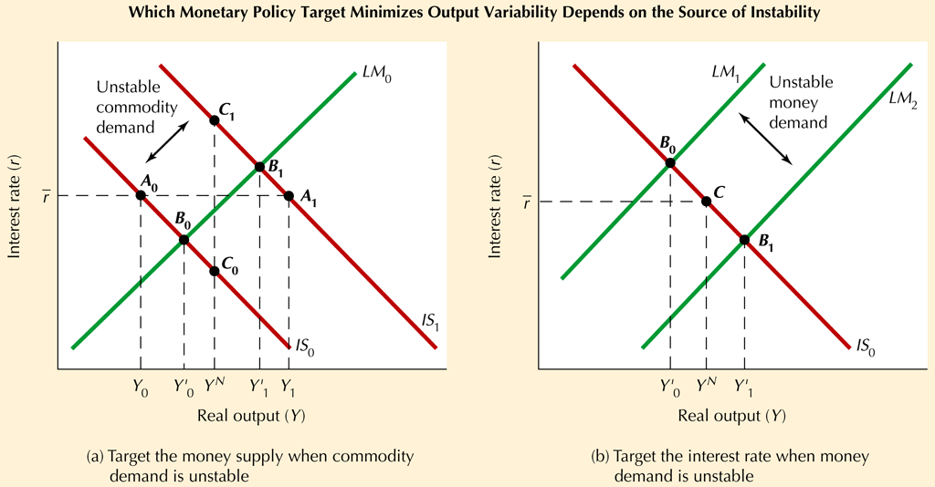

* Difficult for the Fed to target an interest rate. Will push up booms and push down recessions. Why?
* Policy rule selected by Fed determines position of the LM curve.
* Monetary policy acts with a 1-2 year lag. Due to uncertainty this suggests a cautious monetary policy.

Assume money demand is determined by:



The opportunity cost of holding money is



The transactions cost of holding money = k = 2.

Assuming  and  what is the level of money demand at Y=2,500 and R=.08? Find the interest rate and which money supply equals money demand at Y=1,000 and for Y=4,000.

Problem 1a

R0 = q1R - q0 = 1 *.08 - .06 = .02

Md = (kY/2R0).5 = (2*2500/2*.02).5 = 353.5533906

When Y = 1000

Ms = Md => 353.55 = (2*1000/2*R0).5

R0 = 1000/(353.55**2) = .008

.008 = R -.06, R = .068

When Y = 4000

Ms = Md => 353.55 = (2*4000/2*R0).5

R0 = 4000/(353.55**2) = .032

.008 = R -.06, R = .092

Now let  Find level of money demand at Y=2,500, and the interest rate if the money supply is set to this value.

R0 = q1R - q0 = .25*.08 =0 = .02

Md = (kY/2R0).5 = (2*2500/2*.02).5 = 353.5533906

If M = 353.55 and Y = 1000

=> 353.55 = (2*1000/2R0).5, R0 =1000/(353.55**2) = .008

.008 = .25*R, => R = .032

When Y = 4000, R0 = .032, = > R = .128

Suppose the Fed’s policy is to target M. For which values of  given above will the LM curve be steeper? Explain your result.

The LM curve is steeper for part b since money demand is less sensitive to the interest rate ( is smaller). It is so because the opportunity cost of holding money varies less with the interest rate and it is this channel through which interest rates affect money demand in the inventory model.

Note: Recently checking accounts have begun to earn interest which is very close to market rates of interest. The opportunity cost of such accounts, then, varies very little with the market rate of interest. This came about as high interest rates in the 1970s led to the removal of restrictions on how much interest could be paid on such accounts. With a steeper LM curve, spending shocks become less destabilizing.

Problem 2.

Suppose competition in the credit card market drives down the cost of using credit cards. How does this affect money demand?

Clearly money demand will fall and at some time in the future the LM curve will move to the right.

If the Federal Reserve is not sure when this will happen it should keep an eye on the interest rate and when it falls (as the LM curve moves right) the Federal Reserve can reduce the stock of Money and move the LM curve back left.

**Policy Issues**

Friedman viewed the success of an activist monetary policy as problematical due long and variable lags in the effects of monetary policy. Five lags include

1. Data lag – takes time to recognize there is a problem
2. The recognition lag. Changes that occur the first month are usually ignored.
3. The legislative lag. Fiscal policy often needs bills to be passed.
4. The transmission lag. Time between policy decision and implementation.
5. The effectiveness lag. Time between start of policy and when effects show up.

In 1980’s Feb raised and lowered interest rates in anticipation of economy’s overheating or stalling out.

In 1990’s Relationship changed as Feb reacted to actual changes. In 1996-99 prices did not change in response to the rising of the output gap. After 2000 the Fed appears to have lowered the Federal Funds rate too far.

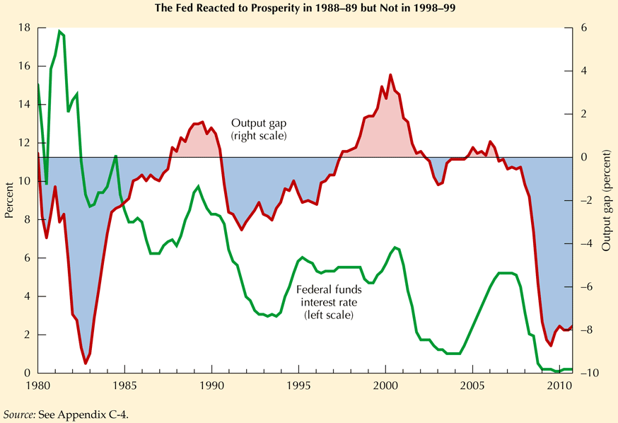

Taylor Rule



Federal Funds Rate = Desired Federal Funds Rate + a times amount inflation is above desired inflation plus b times the output gap  .

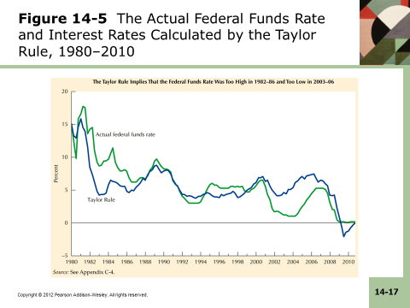

The above graph shows when the Taylor Rule was not being followed. Note that around 2004 the Federal Funds Rate was too low.

Time Inconsistency: (Kydland & Prescott). Policy makers make an optimal decision and private decision makers make decisions based on this announced policy. However at a later time policy makers shift to policy B.

**15.** **The Economics of Consumption behavior**

* Friedman's **permanent income theory** stresses that consumption is a function of permanent income not transitory income. (Income = permanent income + transitory income). Modigliani's **life cycle theory** stresses that families look ahead over their whole life times in forming their consumption decisions.
* Simple treatment using models that can be estimated easily:

Keynesian 

Friedman 



=> 

assume 

=> 

if we lag and multiply by Λ



subtracting gives



Note added term 

* Life cycle suggests Ct = f(Y, W) where W is wealth and Y is disposable income.
* Ct = α + β1Yt + β2Wt-1
* Problem, how do we get wealth?

Wt - Wt-1 = Yt - Ct

Since Ct-1 = α + β1Yt-1 + β2Wt-2

=> [Ct - Ct-1] = β1[Yt - Yt-1] + β2[Wt-1 - Wt-2]

= β1[Yt - Yt-1] + β2[Yt-1 - Ct-1]

=> Ct = β1Yt + [β2 - β1]Yt-1 + [1-β2]Ct-1

* This formulation nests Keynesian and Friedman as special cases of this form of the life cycle model which can be easily tested with data. Extensions include better measures of wealth.

The file consumption.dct loads data on real consumption and real disposable income that is built using a chained index. The data is quarterly from 1947 quarter 2 to 2014 quarter 1 and was obtained from the St. Louis Fed. The Stata commands

Infile using "c:\master\master1\class\e221\consumption.dct",clear

table summary

regress pcecc96 dpic96

regress pcecc96 dpic96 lag_c

regress pcecc96 dpic96 lag_c lag_dpi

Produce:

. do "C:\Users\hhstokes\AppData\Local\Temp\STD00000000.tmp"

. infile using "c:\master\master1\class\e221\consumption.dct",clear

dictionary {

* Data set built 14/ 7/14 at 8:45:18 by b34s

str8 date

double dpic96 `"Real DPI Billions Chained 2009 "'

double pcecc96 `"Real Personal Consumption Chained 2009 "'

double lag_c

_newline

double lag_dpi

}

(268 observations read)

. summary

unrecognized command: summary

r(199);

end of do-file

r(199);

. do "C:\Users\hhstokes\AppData\Local\Temp\STD00000000.tmp"

. infile using "c:\master\master1\class\e221\consumption.dct",clear

dictionary {

* Data set built 14/ 7/14 at 8:45:18 by b34s

str8 date

double dpic96 `"Real DPI Billions Chained 2009 "'

double pcecc96 `"Real Personal Consumption Chained 2009 "'

double lag_c

_newline

double lag_dpi

}

(268 observations read)

. summarize

Variable | Obs Mean Std. Dev. Min Max

-------------+--------------------------------------------------------

date | 0

dpic96 | 268 5435.466 3216.656 1297.4 11766.8

pcecc96 | 268 4864.14 2983.423 1219.3 10859.2

lag_c | 268 4828.096 2969.04 1199.4 10831.5

lag_dpi | 268 5396.456 3202.95 1297.4 11743

. regress pcecc96 dpic96

Source | SS df MS Number of obs = 268

-------------+------------------------------ F( 1, 266) = .

Model | 2.3737e+09 1 2.3737e+09 Prob > F = 0.0000

Residual | 2773082.91 266 10425.1237 R-squared = 0.9988

-------------+------------------------------ Adj R-squared = 0.9988

Total | 2.3765e+09 267 8900810.36 Root MSE = 102.1

------------------------------------------------------------------------------

pcecc96 | Coef. Std. Err. t P>|t| [95% Conf. Interval]

-------------+----------------------------------------------------------------

dpic96 | .9269507 .0019426 477.17 0.000 .9231259 .9307755

_cons | -174.2683 12.26333 -14.21 0.000 -198.4139 -150.1228

------------------------------------------------------------------------------

. regress pcecc96 dpic96 lag_c

Source | SS df MS Number of obs = 268

-------------+------------------------------ F( 2, 265) = .

Model | 2.3762e+09 2 1.1881e+09 Prob > F = 0.0000

Residual | 273760.6 265 1033.05887 R-squared = 0.9999

-------------+------------------------------ Adj R-squared = 0.9999

Total | 2.3765e+09 267 8900810.36 Root MSE = 32.141

------------------------------------------------------------------------------

pcecc96 | Coef. Std. Err. t P>|t| [95% Conf. Interval]

-------------+----------------------------------------------------------------

dpic96 | .0669544 .017495 3.83 0.000 .0325076 .1014013

lag_c | .9322891 .018954 49.19 0.000 .8949694 .9696088

_cons | -.9697312 5.226473 -0.19 0.853 -11.26043 9.320965

------------------------------------------------------------------------------

. regress pcecc96 dpic96 lag_c lag_dpi

Source | SS df MS Number of obs = 268

-------------+------------------------------ F( 3, 264) = .

Model | 2.3763e+09 3 792088315 Prob > F = 0.0000

Residual | 251421.202 264 952.353036 R-squared = 0.9999

-------------+------------------------------ Adj R-squared = 0.9999

Total | 2.3765e+09 267 8900810.36 Root MSE = 30.86

------------------------------------------------------------------------------

pcecc96 | Coef. Std. Err. t P>|t| [95% Conf. Interval]

-------------+----------------------------------------------------------------

dpic96 | .2163254 .0351189 6.16 0.000 .1471767 .2854741

lag_c | .9578264 .0189471 50.55 0.000 .9205198 .995133

lag_dpi | -.1736935 .035863 -4.84 0.000 -.2443075 -.1030796

_cons | 1.162227 5.037437 0.23 0.818 -8.756438 11.08089

------------------------------------------------------------------------------

.

* More advanced treatment of wealth: Family faces **intertemporal budget constraint**. Define

At = assets at beginning of year of year t

Rt = interest rate on assets during year t

Et = income from work during year t

Tt = taxes during year t

Ct = consumption during year t

=> At+1 = At + RtAt + Et - Tt - Ct

* **Implications of forward looking model**:
* Households choose current consumption as a part of lifetime consumption pattern.
* MPC of permanent income close to one.
* Since will not spend transitory income that is added to family assets, in long run consumption will increase by Δ transitory income times the after tax rate of interest.
* Theory assumes household prefer smooth consumption profiles.
* In 1968 LBJ passed the temporary tax surcharge to curb inflation. The economy figured this was temporary and did not reduce their consumption as much as expected. Short run fiscal stimulus, such as tried in 1974-75, did not work as expected since economy figured out what was going on. The implications is that short term activist economic policy does not work as well as expected.
* Why is Japanese savings rate > US savings rate? If an economy is growing, younger people who disproportionately save, will have higher incomes than the older people had when they were young. => savings rate of fast growing country will be > savings rate of slow growing country. Other reasons are tax system in Japan favors savings, not as extensive a social security system and high cost of Japanese housing.
* Rational expectations approach uses forecasted income in consumption function.
* The current level of consumption is the best predictor of future consumption. There is some evidence that consumption is a random walk.
* The evidence from temporary changes in taxes in the 60's and 70's is that consumption changes are small. => fiscal policy that involves ΔT may be weaker that the Keynesian theory predicts.
* The interest rate affects the price of future consumption relative to current consumption. Assuming a positive real rate of interest => an incentive to defer spending.
* If the real rate of interest is higher than the rate of time preference, then people will shift the consumption a bit toward the next year.

Work numerical problem 2 page 291 and numerical problem 5 page 292.

Problem.

Assume C = 220 + .9Yp

Yp = .5(Yt +Yt-1)

Y = disposable income

Problem a. What is consumption in period 2 assuming 

Yp = .5(4000 + 4000) = 4000. => C2 = 220 + .9*4000 = 3820.

Problem b. Now assume Y increases to 5000 in year 3 and remains at that level? What is consumption in year 3 and 4?

C3 = 220 + .9*.5*(5000 + 4000) = 4270

C4 = 220 + .9*.5*(5000 + 5000) = 4720

Problem c. Whit is short run MPC? Long run MPC? Short run MPC = .45

Long run MPC = .90

Problem d. Explain why this formulation of consumption may provide a more accurate description of consumption that the simple consumption function that depends only on current income?

People seek to smooth out their consumption expenditures over time. Therefore they base their consumption expenditure plans on a long-run average of income, or permanent income, rather than on the more variable annual income.

**16 Economics of Investment Behavior**

* Investment the most volatile component of aggregate demand.

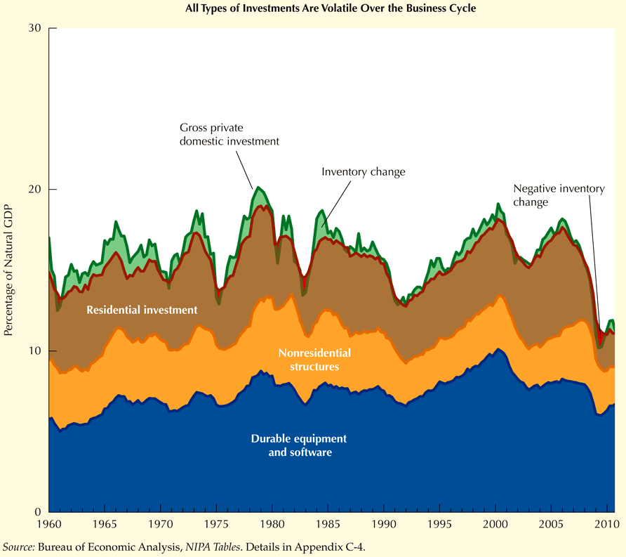

* Residential investment turns early.
* Nonresidential have become less important
* Durable equipment and software investment has become more important
* Inventory investment exhibits sharp but short-lived swings and has become less important due to role of computers managing the supply chain.
* Capital has diminishing marginal product. The marginal benefit of capital schedule is the firms demand for rented capital schedule.
* The demand for capital schedule move out if Y increases since if Y up => N up which in raises the marginal product of capital.
* Determination of rental price of capital:

Pk = price of new machine

R = real interest rate

d = rate of depreciation (at end of year have to spend d times original price to make up for wear and tear)

RK = rental price of the equipment

* RK = (R + d)PK
* Demand for capital declines if RK up.
* Demand for capital rises if planned output rises.
* Demand for capital rises if W down. (substitution effect).
* Define πK = ΔPK /PK, then RK = (R-πK + d)PK . In words, if the rental price of capital depends positively on real interest rate, negatively on the expected change in the price of capital and positively on depreciation.
* K* = desired capital stock.
* K* = .5(W/RK)Y
* If firm wants capital stock to equal desired capital stock.
* I = K*t - Kt-1 = .5(W/RK)Yt - Kt-1
* Investment depends positively on W, negatively on rental price of capital and positively on output. Effect of output on investment is **accelerator**.
* If v = .5(W/RK), then It = vYt - vYt-1 = vΔY. In words the level of investment depends on the change in output.
* The above model assumes complete adjustment in each period. Or 
* Assuming lags I = s(K*t - Kt-1) = s(.5(W/RK)Yt - Kt-1)
* Taxation of capital tends to discourage investment by reducing the earnings the firm receives from its investment.
* Define:

u = tax rate on rental income

z = investment incentive

(1-u)RK = (R+d)(1-z)PK

We equate after tax rental income to after tax cost of renting.

* RK = [(R+d)(1-z)PK]/(1-u)
* Anticipated changes in tax incentives further complicate decision.
* Residential housing equations are similar.
* Housing is most sensitive to real interest rates since d is small relative to R since most houses last a long time.
* Inventories provide a buffer stock to accommodate unexpected changes in demand. If inventories are a fix percentage of expected sales, and this percentage changes, this can imply a shock to aggregate demand due to inventory adjustment.
* Tobin's q. Since investment takes place with a lag for substantial periods of time a firm may be out of adjustment. Let J = marginal benefit of capital and RK = rental price of capital. J/RK > 1 => firm will invest in capital. In the stock market J/MV should equal RK where MV is the market value of outstanding stock. Tobin defined q = MV / PK = j/RK. Investment is positively related to q.

Problem 1.

Assume I = s(K*t - Kt-1), K*t = .1Yt/Rt

R=.05, s=.25 to start

Problem a Calculate the desired capital sock in year 1 if output = 200 and capital was initially = 400.

K* = .1*200/.05 = 400

I = .25(400-400)=0

Problem b Now assume output increases to 250 and remains at this level.

Calculate K, and I in years 2, 3, 4.

K* = .1*250/.05 = 500

year Kt-1 It Kt

2 400 25 425

3 425 18.75 443.75

4 443.75 14.0625 457.8125

Long run K* = 500, I = 0. Note: 18.75 = .25* 75.

Problem c Repeat problem b for s=1 and comment on what occurs.

year Kt-1 It Kt

2 400 100 500

3 500 0.0 500

4 500 0.0 500

=> immediate adjustment of capital stock

Problem d Repeat problem a assuming

 which adds replacement investment

K* = .1*200/.05 = 400

I = .25(400-400) + .1*400 = 40

Problem e

K* = .1*250/.05 = 500

year Kt-1 It Kt

2 400 65 425

3 425 61.25 443.75

4 443.75 58.4380 457.8125

Long run K* = 500, I = 0

Note 65 = 40+25

Problem f now assume immediate adjustment

year Kt-1 It Kt

2 400 140 500

3 500 50 500

4 500 50 500

=> immediate adjustment of capital stock

=> Investment is .1 * Kt-1 + old values

**Chapter 17 Designing and Maintaining a Good Macro Policy**

* **General Principles of Policy analysis**
* When making decisions, people think about the future and their expectations of the future can be modeled by assuming that they have a sense of economic fluctuations and use the information to make unbiased (but not error-free) forecasts. => people use all information to make forecasts.
* Macro economic policy can be usefully described and evaluated as a policy rule, rather than by treating the instruments as exogenous and looking only at one-time changes in these instruments.
* Lucas Critique => policy changes will change the parameters of the underlying model. How relevant is this? Build expectations formation into the model. Sims suggests that there are rarely big policy changes. This suggests that the Lucas critique not all that important.
* In order for a particular policy to work well it is necessary to establish a commitment to that rule.
* **Activist policy** rules involve feedback.
* **Discretionary policy** involves case by case situations.
* **Passive policy rules** involves no feedback.
* The economy is basically stable; after a shock the economy will eventually return to its normal trend paths of output and employment. However, because of rigidities in the economy, this return could be slow.
* The objective of macroeconomic policy is to reduce the size (or the duration) of fluctuations in output, employment, and inflation from normal levels after shocks hit the economy. The objective is to be achieved over a long period of time, which will in general include a larger number of business cycle experiences. Future business cycle fluctuations are not viewed as less important than the current one.
* To analyze policy need **social welfare function**.
* Need # policy instruments = # of targets.
* Inflation is undesirable
* "Shoe-Leather" costs of holding money ( German case)
* Tax distortions (depreciation does not cover replacement) capital gains tax is on nominal returns not real returns.
* Unfair gains and losses (unexpected inflation helps debtors hurts creditors)
* Nonadapting economic institutions (Retirement arrangements are negatively impacted by unexpected inflation.)
* People see inflation as a breakdown of basic government responsibilities.
* People see rising prices and a reduction in real income.
* Unemployment and Y < Y* cause direct costs.
* **Possible improvements in Economy**
* Streamline labor market
* Better job matching
* More appropriate education
* Eliminate Government price and wage fixing. (Davis-Bacon Act prevents contractors from cutting construction costs in a slack market. Governments regulate taxi rates.
* Improve indexation (Note discussion by Clinton of CPI)
* Avoid Government price shocks
* Government promote trade

Problem "Compare a policy of fixing the money stock to a policy of fixing the interest rate. Prepare a brief argument in favor of each type of targeting. List advantages and disadvantages."

Monetary aggregate targeting is easier to achieve and provides a stable, predictable monetary policy allowing for a reasonable long-run average inflation rate. The disadvantage is that it makes no attempt to insulate the economy from price shocks, and so it is in principle far below the optimal policy in terms of social welfare. Interest rate targeting is very difficult since if an error is made on the target serous problems can occur. Assume that the interest rate target is above the market value. Here the Fed will be taking money out of the system to raise the rate. This may drag the economy into recession. If the target interest rate is below the market rate, the Federal Reserve will increase the money supply in an attempt to lower the interest rate. This will cause inflation. The real problem is that appropriate interest rate will differ in different points in the cycle. Targeting the interest also has the same problem at the **free reserves** doctrine that proved disastrous in the 30’s.

**The World Economy**

* As a policy goal, it is desirable to increase trade so that countries can exploit their comparative advantage.
* NAFTA is showing gains for Canada and Mexico.
* GATT provides a mechanism by which tariffs can be reduced.
* International Foreign Exchange unit must deal with:

- Liquidity problem

- Adjustment problem

- Confidence problem

- Seignorage problem

* Flexible exchange rates in Europe give rise to "snake in the tunnel" Note that (A:B)=(A:C)*(C:B). ($:L) = ($:M)*(M:L). EURO fixed this problem but added other problems.
* With high capital mobility and no expected change in the exchange rate, the domestic interest rate will be the same as the world (common market) interest rate unless there is default risk that is country specific.
* Under fixed exchange rate and capital mobility the central bank must keep the interest rate equal to the world interest rate.
* If world inflation is greater than US inflation exchange rate will appreciate.
* Under flexible exchange rate each country can have its own level of inflation. This is not possible under fixed exchange rates.
* The ACA allows employers who have part time workers NOT to pay for health insurance. This is not helpful.

**Summary of 2006- Crisis and what came before:**

1792-1812 First Bank of the US

Needed to regulate issuance of Bank Notes => Force bank to redeem in specie.

1816-1836 Second Bank of the US.

William Jones first president got into difficulty. Langdon Cheves took over in 1819-1822.

Excellent link from Fed

<https://www.google.com/search?q=second+bank+of+the+us+history&ie=utf-8&oe=utf-8>

1836-1864 Bank note Period

Banks allowed to issue notes without much regulation.

1864-1913 National Bank Period

Federally regulated system of national banks that were alone allowed to issue currency. Amount of currency bank was allowed to issue depended on its capital. Difficult to shift money around country. Some bankers in different locations formed clearing houses that help banks in trouble. Panic of 1907 required J. P. Morgan to step in to lend to financial institutions. Show the need for a central bank

1914-Present Federal Reserve System

Acts as a representative of the banking system. Issues currency and is charged to promote growth, price stability and employment. The banking crisis of the 1930’s worsened the depression and made monetary policy ineffective in part was people with drew currency from banks and thereby reduced the money supply.

The Glass-Steagall Act of 1933 separated banks into commercial banks and investment banks. This was repealed in 1996. Regulation Q prevented commercial banks from paying interest on checking accounts. The FDIC insured up to $2,500 of deposits.

In 1980 there was a Savings and Loan Crisis after Congress allowed them to take on more risk. The result was that many failed.

In the late 1990’s derivatives added more risk. Long Term became insolvent and had to be rescued in 1998. Subprime lending led people into housing contracts that they had little possibility to repay. When housing prices began to fall, “flippers” were unable to get out.

Reforms such as Dodd-Frank may not have been enough although its intention was to extend regulation to institutions viewed as “systemically important.” The recovery from the 2007-2008 crisis has been slow.